The Consequences of Multiple-Member Districts in the State Legislature

Lilliard E. Richardson, Jr.  University of Missouri  RichardsonLE@missouri.edu | Christopher A. Cooper  Western Carolina University  ccooper@wcu.edu

*Paper prepared for the 3rd Annual Conference on State Politics and Policy.
Tucson, AZ. March 2003.

A little over thirty-five years ago, Hamilton (1967) proposed thirteen possible effects of multi-member districts (hereafter MMDs). Although scholars have begun to address many of these effects, others remain unexplored—particularly at the state legislative level. Indeed, state and local politics textbooks make scant mention of MMDs. Much of the work on state legislatures and MMDs is plagued by definitional problems. As a result, the impact of MMDs at the state legislative level has remained somewhat elusive. We attempt to shed some light on this question, concentrating on three expected results of MMDs: (1) Do MMDs decrease the number of African-Americans and other minorities in the state legislature; (2) Do MMDs increase the number of women in the state legislature; and (3) Do MMDs reduce incumbency advantage and increase turnover?
These questions are particularly important for state legislative scholars. Four state senates and eleven state houses employ at least some MMDs (Jewell and Morehouse 2001: 219), and all lower chamber districts in Arizona, New Jersey, North Dakota and South Dakota are MMDs. In these states alone, over 15 million citizens are represented by MMDs. Scholars cannot obtain a complete understanding of state legislatures without understanding the representational consequences of MMDs.
In 1955, Klain commented that very little work had been done on MMDs. “No one, apparently, has checked the relevant data in more than half a century. The Council of State Governments has ‘not made a general survey’ and is ‘unable to find any compilation which gives this information for all of states.’ On what sources, then, do the authorities rely? The answer, perhaps is anybody’s guess” (1106). Perhaps the answer is not as negative as it once was, but certainly more attention needs to be paid to the effects of this unique institutional arrangement.

What is a Multi-Member District?
The fifty state legislatures (and 99 chambers) provide tremendous variation on a number of institutional features, including professionalism, party control, term limits, leadership, and committee structure (Hamm and Squire 2001; Moncrief, Thompson, and Cassie 1996). Although many of these subjects have been discussed in depth, scant attention has been paid to patterns of districting in the state legislatures.
All state legislators are elected using a first-past-the-post system (meaning that the candidate who gets the most votes wins), but states differ significantly in the number of seats that represent a given area. This is often referred to as district magnitude (Hamm and Moncrief 1999: 148). The majority of elected officials in the United States represent single-member districts (hereafter SMDs) meaning that only one person represents an electoral district.
In contrast, MMDs are districts where more than one legislator represents the same geographic area. Most MMDs contain two legislators representing the same area, although a few districts still exist with three or more legislators representing the same area. There are five primary types of electoral structures sometimes referred to as MMDs in the American states: Bloc, Bloc with Partial Abstention, Cumulative, Staggered, and Seat. Bloc MMDs consist of free-for-all elections where each candidate for office in the district runs against every other candidate, and the number of seats equals the number of votes each voter receives (Cox 1990). Voters can give only one vote to a candidate, and each voter must use all votes (sometimes called anti-single shot provisions). Bloc with partial abstention is similar except that voters can cast any number of votes up to the limit so in a two-member district (such as Arizona) they may choose to cast either one or two votes in an election. Cox (1990) argues that this distinction is important for strategic reasons, and candidates are more likely to move away from the district median even with a smaller number of candidates in a partial abstention bloc MMD system.
Cumulative MMDs allow a voter to cast more than one vote for a single candidate in the election or to spread the votes among multiple candidates. The cumulative MMD is rare in American state legislatures with the most recent example being Illinois up to 1982. Cox (1990) argues that cumulative MMDs may have a centrifugal impact on ideology similar to bloc MMDs, and Adams (1996) provides some empirical support from Illinois, but otherwise we do not know much about the impact of cumulative MMDs.
Staggered MMDs involve 2 or more legislators representing the same geographic area but elected in different years. Twenty-seven state senates used staggered terms in 1984 (Bullock and MacManus 1987), but they are now quite rare. This structure is equivalent in effect to an SMD when it results in only one seat being contested at a time so it should not be considered a true MMD in most cases.
Other states employ a seat-designate (or post) MMD system in which candidates run for one seat or another (generally designated seat A or seat B), and the district is represented by as many legislators as there are seats on the ballot. Voters are then asked to choose among the candidates for seat A and seat B. “In effect, such systems operate as a series of single-member elections within the same district” (Hamm and Moncrief 1999: 148). Niemi, Jackman and Winsky agree: “So long as we are looking at candidates’ support rather than voter behavior, MMDs with positions can be regarded as equivalent to SMDs…” (1991: 97). The lower houses of the Idaho and Washington state legislatures employ this seat-designate system.
In what follows, we review the literature on MMDs with special emphasis on the electoral impact of MMDs on minorities, women, and incumbents. Throughout this discussion, we make use of a systematic analysis that identifies the major works on the effects of MMDs (presented in Tables 1-3).

Multi-Member Districts and Ethnic Representation
MMDs are generally believed to retard minority representation. In an MMD, the majority is likely to elect all the representatives from a district, whereas if the district were broken into a number of SMDs, at least one of the smaller districts is likely to be represented by a minority group—“especially if minority strength is geographically concentrated” (Grofman, Migalski, and Noviello 1986: 67). In addition, MMDs usually lead to more expensive campaigns, which may impact minority candidates more often than Caucasian candidates.
The vast majority of extant work supports the notion that MMDs are bad for black representation, although MacManus (1978) argues that once one controls for other factors such as urbanism, MMDs do not hinder the representation of minorities. Welch and Karnig (1978) also suggest that at the school board level MMDs may actually advantage minority candidates. Darcy, Hadley and Kirksey (1993), and Rule (1992) also argue that although MMDs are bad for black male representation, MMDs increase the number of black females in office.
[Table 1 About Here]
Unfortunately, the majority of research on the representation of blacks in MMDs has been focused at the city council level (Cole 1974; Davidson and Korbell 1981; Engstrom and McDonald 1981; 1982; 1986; Grofman and Handley 1989; Jones 1976; Karnig 1976; Karnig and Welch 1980; 1982; MacManus 1978; Robinson and Dye 1978; Taebel 1979; Teasley 1987; Jones 1976). Grofman et al. (1986) conducted one of the most thorough looks at the racial consequences of MMDs in the state legislature. By comparing a number of MMD chambers to SMD chambers, they conclude that MMDs disadvantage black candidates. Bullock (1987), Bullock and MacManus (1987), Hamilton (1967), and Moncrief and Thompson (1992) also come to the same conclusion—MMDs are not good for black representation. There is some reason to question this, however. Bullock and Gaddie (1993) examine the shift from MMD to SMD in South Carolina, Florida, and North Carolina. They caution that that although their data generally lead to the same conclusion, more black representation is not an automatic result of switching from MMDs to SMDs. In sum, although we would expect that MMDs advantage white candidates, the lack of work at the state legislative level and some confounding findings lead us to believe that the question deserves to be revisited.

Multi-Member Districts and Representation of Women
MMDs are generally believed to decrease minority representation, but increase the number of female representatives, leaving advocates of descriptive representation in a bit of a quandary. Once again, a considerable amount of headway has been made in the city council (Bullock and McManus 1991; Welch and Karnig 1979) and comparative international contexts (Duverger 1955; Matland and Studlar 1993; Norris 1985; Randall 1982; Rule 1981; 1987; 1994; Vallance 1977; Means 1972; Welch and Studlar 1990), but scholars have been late in addressing this question in the state legislature. The majority of the evidence suggests that women are advantaged by MMDs (Carroll 1994; Darcy, Welch and Clark 1985, 1987; Matland 1993; Matland and Brown 1992; Moncrief and Thompson 1992; Pritchard 1992), but a few scholars argue that the evidence does “not consistently support the developing conventional wisdom that MMDs greatly enhance women’s electability” (Welch and Studlar 1990, 405). Also, some have argued that because MMDs are disproportionately located in urban areas, women candidates may actually fare worse in MMDs than SMDs (Werner 1968; Diamond 1977; Hill 1981).
[Table 2 About Here]
Recent studies at the state legislative level (Arceneaux 2001; Hogan 2001; King 2002) find evidence that MMDs assist in the election of female candidates. King (2002) employs an interrupted time-series analysis of states that shifted from SMDs to MMDs, and also includes four states that were consistently MMD and 4 states that were SMD throughout the period under study. In the end, he concludes that switching from MMD to SMD decreases the representation of women in the state legislature. King’s study encounters a problem in that it includes Idaho, a seat-designate state, as a MMD state.
Arceneaux’s study employs a unique independent variable by estimating a “feminism index” for each state based on public opinion data (see also Brace et al. 2002), but his index is not available for all states. As a result, Arceneaux excludes South Dakota—one of four states that has a chamber entirely composed of MMDs. Further, Arceneaux does not differentiate between seat-designate and free-for-all MMDs—essentially lumping together two distinct concepts.
Limitations of the data, an overemphasis on local elections, and an elastic definition of MMD lead us to question much of the conventional wisdom regarding MMDs. In sum, the question of whether MMDs produce a higher proportion of female state legislators is still open.

Multi-Member Districts, Turnover Rates, and Incumbency Advantage
The turnover rate is a measure of the degree to which new members of a chamber replace existing members of a legislature from one session to the next. Generally, turnover rates have fallen over the last half of the 20th century, lower chambers have higher turnover, and legislatures with four-year terms tend to have higher turnover rates than those chambers with two-year terms (Shinn and Jackson 1979; Niemi and Winsky 1987). Turnover can be influenced by several factors, such as redistricting, legislative professionalism, opportunities for advancement, term limits, legislative salary, and the mood of the electorate (Moncrief, Niemi, and Powell 2003).
One important factor is incumbency advantage and the potential it has to ward off potential challengers. Numerous studies have examined incumbency advantage and determined that MMDs reduce the impact of incumbency advantage (Berry, Berkman, and Schneiderman 2000; Carey, Niemi and Powell 2000; Cox and Morgenstern 1995; Moncrief and Thompson 1992; Niemi and Winski 1987; Squire 2000). This reduced incumbency advantage may combine with the strategic elements of MMD elections to create less certainty for incumbents so MMD legislators may either lose more often or be more willing to voluntarily choose to pursue other opportunities. No one has developed a model of this phenomenon, but the net result is greater turnover in MMD state legislatures.
Related to turnover is whether MMDs affect the tenure of legislators. This question has been debated for over a half century, with little conclusive evidence either way. For instance, Silva (1964) suggests that MMDs produce shorter tenure, but Hyneman’s (1938) study of Indiana legislators finds that MMDs have no impact on tenure.
Of the eight articles in our analysis that address incumbency advantage in MMDs (shown in table 3), six conclude that MMDs decrease incumbency advantage (Berry, Berkman, and Schneiderman 2000; Carey, Niemi and Powell 2000; Cox and Morgenstern 1995; Moncrief and Thompson 1992; Niemi and Winski 1987; Squire 2000), and two conclude that MMDs have no substantive impact on incumbency advantage in the state legislature (Niemi, Jackman, and Winski 1991; Welch and Studlar 1990).
[Table 3 About Here]

Other Effects of Multi-Member Districts
Although we test for only three effects of MMDs in this paper, we would be remiss if we did not point out other potential effects. Scholars have found that MMDs affect ideological extremity, a potential “double disadvantage” for female minority candidates, how political parties operate, the provision of constituency service, and voting turnout.
If the study of city councils has dominated what we know about the representation of minorities in MMDs, then the study of other countries has driven what we know about how MMDs affect ideological extremity. For instance, through an examination of the Chilean legislature, Dow (1998) and Magar, Rosenblum, and Samuels (1998) find that MMDs produce more ideologically extreme legislatures. Gary Cox’s formal model comes to the same conclusion: “when there are more than two candidates competing under ordinary plurality, equilibria are noncentrist; rational vote-seeking politicians have an incentive to avoid bunching at the middle” (1990, 912). Later, Cox tests his formal model with case studies from a variety of countries and concludes that MMDs produce more ideologically extreme legislators (1997).
Only two extant works have looked at this question in the context of the state legislature. In the first, Adams (1996) develops a formal model and tests it with the case of the Illinois House. Adams compares parties in Illinois before and after they reformed their electoral system. Adams concludes that when Illinois moved from an MMD to an SMD system, the legislators became more moderate. Unfortunately, Adams’ empirical test does not apply to pure MMDs because Illinois had a cumulative voting system until 1982, and Cox (1990) argues that cumulative voting systems create different incentives for voters and candidates than pure MMD systems. Adams’ empirical work may be indicative of the effects of cumulative MMD models and the theory may even apply to pure MMDs, but the overall result is that we do not know if pure MMDs create ideological extremity in state legislatures or not.
To evaluate whether a pure MMD system creates ideological extremity, Richardson, Russell, and Cooper (2002) test the hypothesis using data from one term of the Arizona state legislature. Arizona offers an intriguing test because each legislative district is represented by one SMD senator and two pure MMD representatives. The results support the hypothesis in that the MMD House produces more ideologically extreme legislators than the SMD Senate even though they are representing the same geographic districts. The question remains, however, are these results applicable to other states with an MMD system, and does it extend over time?
A few scholars have moved beyond examining female or black representation separately and instead have looked at the “double disadvantage” hypothesis—the idea that black women are discriminated against twice—once for being black and once for being female. Darcy, Hadley and Kirksey (1992), Herrick and Welch (1992), and, Welch and Herrick (1992) find that MMDs elect more women of all races. Because black men in the state legislature have achieved parity with black men in the population overall, Darcy et al. conclude by suggesting that the benefits of MMD for black women outweigh the disadvantages for black men.
Others have suggested that parties operate differently in MMDs. “The role of parties is probably greater in campaigns and elections in multi-member districting systems, as members of the same party tend to run as a team” (Hamm and Moncrief 1999: 148). Although there have been a wealth of studies that have examined the role of parties in state legislative campaigns (Gierzynski and Breaux 1998; Hogan 2002; Jewell and Morehouse 2001), the presence of an MMD is rarely employed as a predictor variable.
Finally, Jewell hypothesizes that legislators in MMDs will be less likely to perform casework (1982a; 1982b) and more likely to act as trustees (1969) than legislators in SMDs. Freeman and Richardson (1995), and Richardson and Freeman (1996) find conflicting results on this matter. Using a four-state survey, they find that legislators representing MMDs receive fewer casework requests than SMD legislators, but the MMD legislators claim to spend more time performing constituency service than legislators in SMDs. These mixed results suggest a question that begs to be revisited.
Finally, other scholars suggest that MMDs lead to higher voter turnout (Bullock and Gaddie 1997), reduced electoral competition (Van Dunk and Weber 1997), and campaigns with more media advertising and reduced voter contact (Jewell 1982b). Although we do not test for these effects here, it should be clear that the hypotheses regarding MMDs are myriad. Existing research has barely scratched the surface.

Why Operationalization Matters
Although the aforementioned literature has provided some important insights into the nature of representation in MMDs, we believe that this review has highlighted a number of inconsistencies in approach that necessitate further investigation. The differences in electoral structure and the resulting incentives for different voter and elite behavior across the different types of MMDs should produce varying results for many of the hypotheses tested by scholars, but most studies have mixed the types together. It is a mistake to conclude that a district is SMD or MMD based on the number of seats alone, and it is likely that there are important distinctions for how each of the institutional arrangements shape behavior. We need more clarification of why different types of MMD would produce certain results (such as minority representation or female representation). Data limitations and conceptual problems have caused many researchers to combine these different types of MMD into one measure testing for a single MMD impact.
Several specific problems emerge. First, scholars often lump seat-designate and free-for-all systems together. As Hamm and Moncrief (1999) suggest, seat-designate systems more closely mirror a series of SMD elections than a true MMD election. When scholars lump the two together, they fail to provide a crucial distinction that may have an impact on a number of key conclusions regarding the impact of MMDs. Second, in studies using upper chamber MMDs it is difficult to know whether data classified as MMD is a true MMD or a staggered term MMD that is essentially a series of SMD elections over different years (similar to the U.S. Senate). Third, we know little about cumulative MMD systems because they are rare, and in many studies the Illinois case (the one main example among states legislatures) may have been included as just another MMD rather than a special case.
In many studies it is also impossible to discern the source for differentiating MMD from SMD legislators. Other times, the authors do not explain what states they include in their MMD or SMD sample. The problems have been so severe that as table 4 shows there is tremendous variation across sources for what states have any kind of MMD system and how many districts, candidates, or elections are considered MMD, much less what type of MMD is in place. The units of analysis are different across some sources, and they cover different years, but this confusion makes replication difficult and hinders our ability to test hypotheses.
[Table 4 About Here]
The literature at the local level has suffered from many of the same problems, although these weaknesses have been acknowledged. Karnig and Welch (1982, 100) suggest, “A simple dichotomy [between MMD and SMD] ignores at least two other differences in electoral structure.” Karnig and Welch also describe a number of other inconsistencies in data collection and analysis.
In sum, we believe that the literature on MMDs in the state legislature is too rife with inconsistencies and measurement questions to confidently make any conclusions as to what effect—if any—MMDs have on state legislatures. In the remaining sections examining the impact of MMDs on minority representation, female representation, and turnover, we will focus our attention on “Pure” MMDs - states with a bloc or bloc with partial abstention system for all districts in the lower chamber and SMD upper chambers. We will contrast the pure MMD with “Pure” SMD states that have had SMD lower and upper chambers since 1974. We exclude Nebraska (because of the unicameral system), Illinois because of the cumulative MMD with a change to SMD in 1982, states with a mixture of SMD and MMD in the same chamber, and any state with staggered MMDs that are essentially SMDs. Seat-designate MMDs are used in some cases to display the sensitivity of the data to the conceptualization of the MMD variable, but such states are never included in the pure MMD figures.
The four pure MMD states are Arizona, New Jersey, North Dakota, and South Dakota. Each of these states has an MMD lower house and an SMD upper house. In addition, the districts in each of these states are configured so that each geographic district is represented by two house members and one senator. This unique system allows us to control for district factors and better isolate the impact of electoral structure on outcomes. Although we eventually plan to extend the study to address other hypotheses, at this point we assess only the impact of MMDs on black representation, female representation, and turnover.

Assessment of Multi-Member Districts
The three hypotheses with the most empirical evaluation in the literature are 1) MMDs reduce representation for African American legislators, 2) MMDs increase female representation, and 3) MMDs decrease incumbency advantage and therefore increase turnover in membership. We expand hypothesis 1 by examining all minority representation in addition to black representation. Data on black representation come from the Joint Center for Political and Economic Study’s Roster of Black Elected Officials, the data on Latinos and Asian Americans come from Fairvote.org, and the data on Native Americans comes from the National Conference of State Legislatures web site. Data regarding female representation come from the Center for American Women and Politics at Rutgers University. Turnover data come from the Book of the States, published biannually by the Council of State Governments.

Minority Representation
The vast majority of the studies on the racial impact of MMDs in American states have focused on African Americans. Figure 1 shows the difference between the percent of the population that is black in a state and the percent of black legislators for Pure SMD states, Seat MMD states, and the Pure MMD states from 1975-2002. A larger figure reveals a greater disparity so upper chambers in the Pure SMDs have the most extreme under-representation. Because of a smaller number of senatorial districts, larger districts where minority votes are more likely to be diluted and more costly senatorial campaigns, the big gap in the SMD upper chambers is not surprising.
(Figure 1 about here)
The surprising result is that the pure MMD states have the smallest gap of the lower chambers, and the difference between the Senate under-representation and the House gap is much larger than for the other two types. Because the districts in the upper and lower chambers of the pure MMD states are the exact same, this comparison is striking. The MMD lower chambers are far more representative than the SMD upper chambers in these four states. One could argue that this result is because Arizona, South Dakota, and North Dakota have a small percent of African Americans, but New Jersey is one of the pure MMD states and it has close to 14% black population. Further, the two Seat states are Washington and Idaho, both of which also have small black populations.
Research on the impact of MMDs on descriptive representation has ignored minorities other than African Americans, and one of the problems is access to data for other minority legislators. We found data for Latino, Asian American, and Native American legislators for only 3 years (2000, 2001, and 2003), and combined it with the data on black legislators. Although blacks make up a small percent of the population in Arizona, South Dakota, and North Dakota, there are sizable populations of Latinos and Native Americans. According to the Census Bureau, the total minority percentages in 2003 are 30.2% for Arizona, 31.9% in New Jersey, 7.3% in North Dakota, and 10.9% in South Dakota. Figure 2 shows the combined under-representation of all four of these minority groups. The Pure MMDs had the least under-representation of all electoral types, and the gap between the house and senate was greatest for the Pure MMD states. The high figure of over 10% in the senates (which are SMDs that share the same geographic district lines as the MMD houses) contrasts sharply with the much lower figure of 6% in the lower chambers, and this result completely contradicts the hypothesis that MMDs create under-representation of minorities.
(Figure 2 about here)
Turning to the individual minority groups, Figure 3 breaks down this under-representation by looking at the gap between population percents and legislator percents for the lower chambers in each of the electoral structures. The data in figure 1 covering 28 years showed a small gap for blacks in pure MMDs, but figure 3 using current data shows that the gap has disappeared for blacks in the pure MMD states. Also, the under-representation of blacks continues to be worse in the pure SMD and Seat types. Further, the minority group that appears to be faring the worst in terms of under-representation across all district types are Latinos, who are particularly disadvantaged by the Seat system.
(Figure 3 about here)
Overall, there is no evidence that minorities are disadvantaged by MMDs when used in all districts in a chamber, and this finding is contrary to the conventional wisdom. Further, mixing Seat states with pure MMDs confuses the picture because the two types exhibited different patterns in every graph on minority representation.

Gender
The previously discussed literature review of MMD impacts on gender representation shows broad, but not universal, support for the idea that MMDs help elect more female state legislators. Further, scholars have shown that the percent of female legislators in a chamber affects the likelihood that women will speak out and participate in debate, and bills pertaining to women, children and families are more likely to be proposed, considered a high legislative priority and passed in chambers with more women (Flammang 1985; Saint-Germain 1990; Thomas 1991). In addition, Thomas argues that less than 10% female representation in a chamber results in “little chance of [women] passing their own bills much less having their priorities influence others” (1991, 973). Finally, work by Kanter (1977) on groups (but not state legislatures specifically) suggests that a minority group must meet at least a 15% threshold to avoid the perception as tokens.
An assessment of female representation from 1975 to 2002 shows that women are better represented in pure MMD states than pure SMD states. Almost 20% of the legislators in the pure MMD lower chambers have been females during this time period versus only 17.2% in the pure SMD states. Further, the upper chambers in the pure MMD states have had 13.6% females over time so there has been a sizable gap between the chambers in MMD states. In both the comparison across states to other lower chambers and within states compared to SMD upper chambers the MMD houses fare better in terms of female representation.
How strong is this finding across time and states? Figure 4 shows that most of the credit for electing women in the MMD lower chambers goes to Arizona. All four of the pure MMD states perform better than pure SMD houses in the late 1970s and early 1980s, but only Arizona exhibited substantial gains across time. In some instances Arizona has had double the percent of female legislators over the other pure MMDs and the average for SMDs.
(Figure 4 about here)
The other three pure MMD states show some early advantages over the pure SMD states, but they have remained stagnant and fallen behind the pure SMD states since 1993. These findings are curious. Two of these states (NJ and ND) rank nearly as high as Arizona on the feminism index created by Arceneaux (2001) so it cannot be explained purely by voter ideology. Further, demographic factors, such as percent college educated, % white collar, low percent of farmers, and % minority, that were significant predictors of electoral success for female candidates in Hogan’s (2001) study should contribute to greater female representation in New Jersey so that explanation does not work well either. None of these three states are considered traditional political cultures either so the mystery remains.
Another concern is whether the results hold up over time. In Figure 5 the female percent in each chamber of the pure SMD and pure MMD states are shown over time since 1975. It is important to point out that the upper chambers in the states with pure MMD houses are listed as S MMD even though the senates are SMD. The figure shows a considerable advantage in the MMD lower chambers versus the SMD houses over time. For many years the difference is around 5%, but since 1993 the gap has narrowed until the SMD houses passed the MMD houses in 2001. Because most research on this topic was conducted throughout the “Large Gap” years of the 1980s and early 1990s, it is not surprising that they determined that MMDs help female candidates. But the data from the new millennium does not support this contention. Further, even the sizable advantage that all lower chambers had over upper chambers narrowed considerably in 2002. Without multivariate analysis to assess the impact of open seats, redistricting, term limits, and changes in campaign finance it is difficult to determine the causes of this change, but the conventional wisdom may need revision.
(Figure 5 about here)
Returning to the issue of concept operationalization, figure 6 provides dramatic evidence for how different Seat systems are than pure MMD systems. Both Idaho and Washington have seat-designate (or post) systems, and they both have much greater female representation than either pure MMD states or the SMD states. If one were to mistakenly include seat-designate states into a MMD variable, it would seriously change the measurement of the impact. Idaho is consistently 5 points higher than the pure MMD average, and Washington is more than 10 points higher and sometimes double the pure MMD average. If these states were included as MMD states, then such figures would inflate the estimates of the impact of MMD on female representation. Alternatively, putting them in the SMD category would cause even greater problems for most of the years from 1975 to 2000.
(Figure 6 about here)
Turnover
Generally, turnover rates for both lower and upper chambers dropped from the early 1970s until 1988 when senate averages were slightly above 15% and house averages were below 18%. Turnover rates increased somewhat in the early 1990s, and the impact of numerous term limit initiatives created higher turnover rates in the late 1990s. Because term limits started to affect legislators after 1994 and the Book of the States changed its method of calculating turnover rates after 1994, we first examined the turnout data for 1974-1994 only.
As figure 7 shows turnover rates were slightly higher for pure MMD lower chambers than either seat or SMD houses. This lends some credibility to the hypothesis. But when we examine the upper chamber figures for the states in each category we see that the senates in the pure MMD states have much higher turnover rates than the senates in the other two electoral structures. There are a few alternative explanations. One, it may be that pure MMD house members facing more uncertainty jump into senate races more readily so there is more turnover in the upper chamber too. The main problem with this is that the Seat MMD house turnover rate is only slightly lower than the MMD lower chambers, but the senates in the Seat MMD states have rates five percentage points lower. The seat representatives face similar uncertainty and yet similar familiarity to a district they already represent, but they do not unsettle the upper chamber as much as the Pure MMD representatives.
(Figure 7 about here)
Second, the pure MMD states may have more competitive parties so there is more legislative turnover. Several of the pure SMD states (AL, LA, SC, TN, and TX) experienced one-party Democratic Party dominance throughout much of this time period so they may not have had much turnover. Interestingly, dropping these Southern states increases the turnover rate of either chamber for the SMD states by less than half a percentage point. Further, the 4 to 5 point gap between lower and upper chambers, for the SMD and Seat types, respectively, remain much higher than the 1.5-point chamber gap in the pure MMDs.
A third explanation is that cultural differences and the political environment in the pure MMD states are different so both chambers are higher than the states in the other two types. From this view, the narrow gap would suggest that the difference in electoral structure between the MMD house and SMD senate in these states was not a contributing factor to the higher turnover. None of these explanations can be ruled out with this data.
One final question about turnover is whether this older pattern persists today. Thanks to the work of Moncrief, Niemi and Powell (2003) and their motivation to post their conference paper early, we obtained their turnover rates for the decade of the 1970s, 1980s, and 1990s and compared them for the pure MMD and pure SMD states. As one can see in figure 8, the pure MMD lower chambers continued to experience the highest turnover rates in the 1990s. The house MMD’s turnover rate is about 7 percentage points higher than the SMD lower chambers. Also, it is apparent that there is little difference between the upper and lower chambers in the pure SMD states, but there is a large gap between the two chambers in the pure MMD states of the 1990s. This finding confirms the hypothesis that MMDs lead to greater turnover, but the higher senate figures for the 1970s create some confusion in that these SMD chambers should not have seen greater turnover than the MMD lower chambers in the same states. Further, term limits are a confounding factor for the 1990s data because half of the pure MMD states enacted term limits during this decade, but only 30% of the SMD states passed and implemented term limits in the 1990s. Clearly, more analysis is needed.

Conclusion
Despite the long history of using MMDs in England, the House of Burgesses from its inception in 1619, most of the American colonies, and 36 state legislatures encompassing 45 percent of the legislative seats in 1950s (Klain 1955), the use of MMDs in the American states has declined drastically over the last few decades. Despite concerns that a switch to SMDs would destroy a “sense of history and community” and create “an artificial anatomy” (Klain 1955), states switched to SMDs for several reasons including the belief that SMDs encouraged more moderate legislators seeking the median voter, that minority parties would not be as disadvantaged by SMDs as they are by MMDs, and that SMDs were more advantageous to minority representation (especially African Americans) than MMDs. These arguments in favor of SMDs are empirical questions that have been addressed by political science, but there have been too few studies, the conceptualization of MMDs has been too convoluted, and the data on which seats in each state are MMDs has been fragmentary, elusive, and inconsistent. As Klein argued in 1955, “where is the evidence?” (1117).
In this paper we sought to clarify the different types of MMD systems, to determine which states had each type of MMD over the last few decades, assess the impact of MMDs as measured in other studies, show the importance of concept operationalization, and provide some preliminary data on three major hypotheses associated with MMDs. The three hypotheses we examined were 1) do MMDs disadvantage minority candidates, 2) do MMDs advantage female candidates, and 3) do MMDs lead to greater turnover in legislative chambers?
Scholars have used a variety of research design approaches to address these three hypotheses, and we tried a different alternative. We compared the states with only SMD districts in the lower chambers with states that used MMD districts exclusively in their lower chambers during the time from 1974-2003. In addition, all of these states had SMD upper chambers so that we could further isolate the effect of MMDs. Also, we examined states with a seat-designate or post system of MMDs in lower chambers throughout this time frame to reveal the importance of concept operationalization by comparing the pattern for seat versus pure MMD states.
The conventional wisdom that minorities are disadvantaged by MMDs was not supported by our data. The pure MMD lower chambers provide representation more proportional to the percent of the minority population than either SMD lower chambers in other states or the SMD upper chambers in their own states. Further, blacks achieved more proportional representation than either Asian Americans or especially Latinos, and neither of these groups fared any worse in pure MMD states than in pure SMD states.
The consensus that MMDs help female legislative candidates is not supported by the data. In the late 1970s and early 1980s pure MMDs appear to have helped female representation, but this is not the case today as SMD lower chambers have surpassed pure MMD states. Further, almost all of the credit for the difference was just the state of Arizona, and the other pure MMD states have lagged behind since the early 1990s. Further, because Seat MMD states have had the highest percent of female legislators over the last couple of decades, operationalization of the MMD concept is crucial to understanding the impact of the institutional structure.
Finally, the results for the membership turnover hypothesis are somewhat mixed. The pure MMD lower chambers have higher turnover rates than other lower chambers, and the pure MMD houses have higher turnover rates than the senates in their state for the 1980s and 1990s. On the other hand, the senates in the MMD states had higher turnover rates in the 1970s, and the gap between the two chambers in the MMD states is much smaller than in pure SMD states. Further, the higher turnover rates in the 1990s may be related to the higher rates of term limits in the MMD states than the SMD states so the relationship between MMD and turnover is not clear.
Results in previous studies may be attributable to the inclusion of seat-designate or post MMD states, confusion over the operationalization of the MMD types, usage of other data (such as those states that changed from MMD to SMD), and possible time-bound results. We showed that operationalization of the MMD concept is important to understanding the impact of the institutional structure, particularly for the Seat MMDs that operate in a manner similar to SMDs and should not be expected to behave in a manner similar to pure MMDs. In addition, some of these hypotheses may have been more accurate in the 1970s and 1980s, but recent experience argues against them. Overall, our results question the conventional wisdom on the impact of MMDs for both minority and female legislators and provide only weak support for the turnover hypothesis.

Works Cited
Adams, Greg D. 1996. “Legislative Effects of Single-Member vs. Multi-Member Districts.”
American Journal of Political Science 40: 129-44.

Arceneaux, Kevin. 2001. “The ‘Gender Gap’ In State Legislative Representation: New Data to
Tackle an Old Question.” Political Research Quarterly 54: 143-60.

Berry, William D., Michael B. Berkman, and Stuart Schneiderman. 2000. “Legislative
Professionalism and Incumbent Reelection: The Development of Institutional Boundaries.” American Political Science Review 94: 859-74.

Black Elected Officials: A National Roster. Various Years. Washington, DC: Joint Center for Political and Economic Development.

Book of the States. Various Years. Lexington, KY: Council of State Governments.

Brace, Paul, Kellie Sims-Butler, Kevin Arceneaux, and Martin Johnson. 2002. “Public
Opinion in the American States: New Perspectives Using National Survey Data.” American Journal of Political Science 46: 173-89.

Bullock, Charles S. 1987. “Redistricting and Changes in the Partisan and Racial Composition of
Southern Legislatures.” State and Local Government Review 19: 62-67.

Bullock, Charles S., and Ronald Keith Gaddie. 1993. “Changing From Multimember to Single-
Member Districts: Partisan, Racial, and Gender Consequences.” State and Local Government Review 25: 155-63.

Bullock, Charles S., and Ronald Keith Gaddie. 1997. “Contestation and Turnout in Multi-
Member and Single-Member Districts.” Southeastern Political Review 25: 751-66.

Bullock, Charles III, and Susan MacManus. 1987. “The Impact of Staggered Terms on
Minority Representation.” Journal of Politics 49: 543-52.

Bullock, Charles III, and Susan MacManus. 1991. “Municipal Electoral Structure and the
Election of Councilwomen.” Journal of Politics 53: 75-89.

Carey, John M., Richard G. Niemi, and Lynda W. Powell. 2000. “Incumbency and the
Probability of Reelection in State Legislative Elections.” Journal of Politics 62: 671-700.

Carroll, Susan J. 1994. Women as Candidates in American Politics, Second Edition.
Bloomington, IN: Indiana University Press.

Center for American Women and Politics. 2001. Various years. “Fact Sheet: Women in State Legislatures.” New Brunswick, NJ: Eagleton Institute of Politics: Rutgers University.

Cole, Leonard A. 1974. “Electing Blacks to Municipal Office.” Urban Affairs Quarterly 10:
17-39.

Cox, Gary W. 1990. “Centripetal and Centrifugal Incentives in Electoral Systems.” American
Journal of Political Science 34: 903-35.

Cox, Gary W. 1997. Making Votes Count: Strategic Coordination in the World’s
Electoral Systems. New York: Cambridge University Press.

Cox, Gary W., and Scott Morgenstern. 1995. “The Incumbency Advantage in Multimember
Districts: Evidence from the U.S. States.” Legislative Studies Quarterly 20(3): 329-49.

Darcy, R., Charles D. Hadley, and Jasohn F. Kirksey. 1993. “Election Systems and the
Representation of Black Women in American State Legislatures.” Women and Politics 13: 73-89.

Darcy, Robert, Susan Welch, and Janet Clark. 1985. “Women Candidates in Single-and Multi-
Member Districts.” Social Science Quarterly 66: 945-53.

Darcy, Robert, Susan Welch, and Janet Clark. 1987. Women, Elections, and Representation.
New York: Longman.

Davidson, Chandler, and George Korbel. 1981. “At Large Elections and Minority Group
Representation: A Reexamination of Historical and Contemporary Representation on
City Councils.” Social Science Quarterly 63: 99-114.

Diamond, Irene. 1977. Sex Roles in the Statehouse. New Haven, CT: Yale University Press.

Dow, Jay K. 1998. “A Spatial Analysis of Candidates in Dual Member Districts: The
1989 Chilean Senatorial Elections.” Public Choice 97: 119-42.

Duverger, Maurice. 1955. The Political Role of Women. Paris: The United Nations Economic and Social Council.

Dye, Thomas R., and Susan A. MacManus. 2003. Politics in States and Communities, Eleventh
Edition. Upper Saddle River, NJ: Prentice Hall.

Engstrom, Richard, and Michael McDonald. 1986. “The Effect of At-Large Versus District
Elections on Racial representation in U.S. Municipalities.” In Electoral Laws and Their Political Consequences. B. Grofman, and A. Lijphart, eds. New York: Agathon Press.

Engstrom, Richard, and Michael McDonald. 1982. “The Underrepresentation of Blacks on City
Councils: Comparing the Structural and Socioeconomic Explanations for South/ Nonsouth Differences.” Journal of Politics 44: 1088-99.

Engstrom, Richard, and Michael McDonald. 1981. “The Election of Blacks to City Councils.”
American Political Science Review 75: 344-55.

Flammang, Janet A. 1985. “Female Officials in the Feminist Capital: The Case of Santa Clara County.” Western Political Quarterly 38: 94-118.

Freeman, Patricia K., and Lilliard E. Richardson, Jr. 1996. “Explaining Variation in
Casework Among State Legislators.” Legislative Studies Quarterly 21: 41-56.

Gierzynski, Anthony and David A. Breaux. 1999. “The Financing Role of Parties.” In
Joel A. Thompson and Gary F. Moncrief, eds. Campaign Finance in State Legislative Elections. Washington DC: CQ Press.

Grofman, Bernard, and Lisa Handley. 1989. “Black Representation: Making Sense of Electoral
Geography at Different Levels of Government.” Legislative Studies Quarterly 14: 265-79.

Grofman, Bernard, and Michael Migalski, and Nicholas Nociello. 1986. “Effects of
Multimember Districts on Black Representation in State Legislatures.” Review of Black Political Economy 14: 65-78.

Hamilton, Howard D. 1967. “Legislative Constituencies: Single-Member Districts, Multi-
Member Districts, and Floterial Districts.” Western Political Quarterly 20: 321-40.

Hamm, Keith E., and Gary F. Moncrief. 1999. “Legislative Politics in the States.” In
Virginia Gray, Russell L. Hanson, and Herbert Jacob, eds. Politics in the American States: A Comparative Analysis, Seventh Edition. Washington DC: CQ Press.

Hamm, Keith E., and Peverill Squire. 2001. “A ‘Tools of the Trade’ Look at Comparing
Congress with State Legislatures.” Paper delivered at the 2001 Annual Meeting of the American Political Science Association, San Francisco, CA. August 29-September 2.

Herrick, Rebekah, and Susan Welch. 1992. “The Impact of At-Large Elections on the
Representation of Black and White Women.” National Political Science Review 3: 62-77.

Hill, David B. 1981. “Political Culture and Female Political Representation.” Journal of
Politics 43:159-68.

Hogan, Robert E. 2001. “The Influence of State and District Conditions on the Representation
of Women in State Legislatures.” American Politics Research 29: 4-24.

Hogan, Robert E. 2002. “Candidate Perceptions of Political Party Campaign Activity in
State Legislative Elections.” State Politics and Policy Quarterly 2: 66-85.

Hyneman, Charles S. 1938. “Tenure and Turnover of the Indiana General Assembly II.”
American Political Science Review 32: 311-331.

Jewell, Malcolm E. 1969. Metropolitan Representation: State Legislative Districting in Urban
Counties. New York: National Municipal League.

Jewell, Malcolm E. 1982a. Representation in State Legislatures. Lexington, KY: University of
Kentucky Press.

Jewell, Malcolm. 1982b. “The Consequences of Single- and Multi-Member Districts.” In
B. Grofman, A. Lijphart, R. McKay and H. Scarrow, eds. Representation and Redistricting Issues, Lexington, MA: DC Heath.

Jewell, Malcolm E., and Sarah M. Morehouse. 2001. Political Parties and Elections in
American States, Fourth Edition. Washington DC: CQ Press.

Jones, Clinton. 1976. “The Impact of Local Election Systems on Black Representation.” Urban
Affairs Quarterly 11: 345-56.

Kanter, Rosabeth M. 1977. “Some Effects of Proportion on Group Life: Skewed Sex Ratios and Response to Token Women.” American Journal of Sociology 82: 965-90.

Karnig, Albert. 1976. “Black Representation on City Councils” The Impact of District Elections
and Socioeconomic Factors.” Urban Affairs Quarterly 12: 223-42.

Karnig, Albert, Susan Welch. 1980. Black Representation and Urban Policy. Chicago:
University of Chicago Press.

Karnig, Albert, and Susan Welch. 1982. “Electoral Structure and Black Representation on City
Councils.” Social Science Quarterly 63: 99-114.

King, James D. 2002. “Single-Member Districts and the Representation of Women in American
State Legislatures: The Effects of Electoral System Change.” State Politics and Policy Quarterly 2: 161-75.

Klain, Maurice. 1955. “A New Look at the Constituencies: The Need for a Recount and a
Reappraisal.” American Political Science Review 49: 1105-19.

MacManus, Susan. 1978. “City Council Election Procedures and Minority Representation.”
Social Science Quarterly 59: 133-41.

Magar, Eric, Marc R. Rosenblum, and David Samuels. “On the Absence of Centripetal
Incentives in Double-Member Districts.” Comparative Political Studies 31: 714-39.

Matland, Robert E. 1993. “Institutional Variables Affecting Female Representation in National
Legislatures: The Case of Norway.” Journal of Politics 55: 737-55.

Matland, R.E., and D. D. Brown. 1992. “District Magnitude’s Effect on Female Representation
in U.S. Legislatures.” Legislative Studies Quarterly 17: 469-92.

Matland, R.E., and Donley T. Studlar. 1993. “The Contagion of Women Candidates in Single-
Member District and Proportional Representation Electoral Systems: Canada and Norway.” Journal of Politics 58: 707-33.

Means, Ingunn Norderval. 1972. “Political Recruitment of Women in Norway.” Western Political Quarterly 25(3): 491-521.

Moncrief, Gary F., Richard G. Niemi, and Linda W. Powell. 2003. “Time, Turnover and Term Limits: Trends in Membership Turnover in U.S. State Legislatures.” Presentation to the 3rd Annual State Politics and Policy Conference, Tucson AZ, March 14-15, 2003.

Moncrief, Gary F. and Joel A. Thompson. 1992. “Electoral Structure and State Legislative
Representation: A Research Note.” Journal of Politics 54(1): 246-56.

Moncrief, Gary F., Joel A. Thompson, and William Cassie. 1996. “Revisiting the State of U.S.
State Legislative Research.” Legislative Studies Quarterly 21: 301-35.

Niemi, Richard, Jeffrey Hill, and Bernard Grofman. 1985. “The Impact of Multimember
Districts on Party Representation in U.S. State Legislatures.” Legislative Studies Quarterly 10: 441-55.

Niemi, Richard, Simon Jackman, and Laura Winski. 1991. “Candidacies and Competitiveness
in Multimember Districts.” Legislative Studies Quarterly 16: 91-109.

Niemi, Richard, and Laura Winski. 1987. “Membership Turnover in U.S. State Legislatures”
Trends and Effects of Districting.” Legislative Studies Quarterly 12:115-23.

Norris, Pippa. 1985. “Women’s Legislative Participation in Western Europe.” Western
European Politics 8: 90-101.

Pritchard, Anita. 1992. “Changes in Electoral Structures and the Success of Women
Candidates” The Case of Florida.” Social Science Quarterly 73: 62-70.

Randall, Vicky. 1982. Women in Politics. London: Macmillan.

Richardson, Lilliard E., Brian E. Russell, and Christopher A. Cooper. 2002. “Legislative
Representation in a Single-Member versus Multiple-Member District System: The Arizona State Legislature.” Unpublished Manuscript: University of Missouri.

Richardson, Lilliard E., and Patricia K. Freeman. 1995. “Gender Differences in
Constituency Service Among State Legislators.” Political Research Quarterly 48: 169-80.

Robinson, Theodore P., and Thomas Dye. 1978. “Reformism and Black Representation on City
Councils.” Social Science Quarterly 59: 133-41.

Rosenthal, Alan. 1998. The Decline of Representative Democracy. Washington DC: CQ Press.

Rule, Wilma. 1981. “Why Women Don’t Run: The Critical Contextual Factors in Women’s
Legislative Recruitment.” Western Political Quarterly 34: 60-77.

Rule, Wilma. 1987. “Electoral Systems, Contextual Factors and Women’s Opportunity for
Election to Parliament in 23 Democracies.” Western Political Quarterly 40: 477-98.

Rule, Wilma. 1990. “Why More Women Are State Legislators: A Research Note.” Western
Political Quarterly 43: 437-48.

Rule, Wilma. 1992. “Multimember Legislative Districts: Minority and Anglo Women’s and
Men’s Recruitment Opportunity.” In Wilma Rule and Joseph F. Zimmerman, eds. United States Electoral Systems: Their Impact on Women and Minorities. New York: Greenwood Press.

Rule, Wilma. 1994. “Women’s Representation and Electoral Systems.” PS: Political Science
and Politics 27: 689-92.

Saint-Germain, Michelle. 1990. “Does their Difference Make a Difference: The Impact of Women Public Policy in the Arizona Legislature.” Social Science Quarterly 70: 956-68.

Shinn, Kwang S., and John S. Jackson III. 1979. “Membership Turnover in U.S. State Legislatures: 1931-1976.” Legislative Studies Quarterly 4: 95-104.

Silva, Ruth C. 1964. “Compared Values of the Single-and the Multi-Member Legislative
District.” Western Political Quarterly 17(3): 504-16.

Squire, Peverill. 2000. “Contested Seats in State Legislative Elections.” Legislative
Studies Quarterly 25(1): 131-46.

Taebel, Delbert. 1979. “Minority Representation on City Councils.” Social Science Quarterly
60: 142-52.

Teasley, C.E. 1987. “Minority Vote Dilution: The Impact of Election System and Past
Discrimination on Minority Representation.” State and Local Government Review 19: 95-100.

Thomas, Sue. 1991. “The Impact of Women on State Legislative Policies.” Journal of Politics 53(4): 958-976.

Vallance, Elizabeth. 1977. Women in the House. Atlantic Highlands, NJ: Humanities
Press.

Van Dunk, Emily, and Ronald E. Weber. 1997. “Constituency-Level Competition in the
U.S. States 1968-1988: A Pooled Analysis.” Legislative Studies Quarterly 22: 141-59.

Welch, Susan, and Donley T. Studlar. 1990. “Multi-Member Districts and the Representation of
Women: Evidence From Britain and the United States.” Journal of Politics 52: 391-412.

Welch, Susan, and Albert Karnig. 1978. “Minority Representation on City Councils.” Social
Science Quarterly 59: 162-22.

Welch, Susan, and Albert Karnig. 1979. “Correlates of Female Office Holding in City Politics.”
Journal of Politics 41: 478-91.

Welch, Susan, and Rebekah Herrick. 1992. “The Impact of At-Large Elections on the
Representation of Minority Women.” In Wilma Rule and Joseph Zimmerman, eds. United States Electoral Systems: Their Impact on Women and Minorities. New York: Greenwood Press.

Werner, Emmy. 1968. “Women in the State Legislatures.” Western Political Quarterly 21:40-50.

Table 1: Race and Multi-Member Districts
Article | States in the Analysis as MMD | Dependent Variable | Independent Variable(s) | Conclusion
Bullock and Gaddie (1993) | FL, NC, SC | Gain or loss in black seats | Time when state switches from SMD to MMD | MMDs generally decrease black representation—although the switch to SMD did not help in all of the states
Jones (1976) | 171 Cities in 1972 | Black % of city council seats/Black % of city population | At large systems, district systems, # of seats in at-large systems, % of population in each district unit, region | MMDs decrease black representation
Teasley (1987) | 141 cities w/ black population of 10% or more in 1971 | % black on council | Black population, at large election, registration discrimination, black/white income differential | MMDs decrease black representation
Grofman, Migalski, and Nociello (1986) | AL, GA, LA, SC, TN, MD, FL after switch, part of NC 1977-1982 | # of black representatives | SMD/MMD | MMDs decrease black representation
Karnig (1976) | 139 city councils in cities with population > 25,000, where blacks >15% of the population | Black % on council/ black % of city’s population | At large elections, district elections | MMDs decrease black representation
Bullock and MacManus (1987) | MMD States not listed | Black representation | MMD, Incumbency,  Size of legislature,  Federal pre-clearance coverage,  Black population %,  At-large system,  Time,  South / Nonsouth | MMDs decrease black representation
Grofman and Handley (1989) | Cities | Black representation | South/Nonsouth,  At-large/SMD | MMDs decrease black representation
Moncrief and Thompson (1992) | Combo of SMD and nonseat MMDs in same states- AZ, IN, NV, NJ, NC, ND, SD, VT, WV, WY | % black seats | SMD/MMD, Urban/Rural | MMDs decrease black representation

Table 2: Sex and Multi-Member Districts
Article | States in the Analysis as MMD | Dependent Variable | Independent Variable(s) | Conclusion
Arceneaux (2001) | AZ, IN, MD, NH, NJ, NC, ND & WV | Avg. proportion of women holding state elective office from 1974-1996 | MMD= % of seats that come from MMDs, culture, feminism, urban, democratic control, female labor force, attractiveness of legislative office, ideology | MMDs increase female representation
Carroll (1994) | Not clear | - | - | More women are recruited in MMDs, thus MMDs increase female representation
Bullock and Gaddie (1993) | FL, NC, SC | Gain of female seats | Time when state switches from SMD to MMD | MMDs made no differences in SC and NC, but did make a difference in Florida.
Bullock and MacManus (1991) | City councils | % of females on council | Type of election system (at large or not), Majority v. plurality, Staggered v simultaneous terms, Council size, Length of term, Incumbency, City size, Region | MMDs do not promote the election of women
Matland and Brown (1992) | NC and NH (both have MMD and SMD systems) | Proportion of each legislative delegation that is female, Arcine of the square root of the proportion | Urbanization, State political culture, time, strong parties, democratic % of seats in district delegation or the Demo % of votes in district | MMDs increase female representation
Moncrief and Thompson (1992) | Combo of SMD and nonseat MMDs in same states- AZ, IN, NV, NJ, NC, ND, SD, VT, WV, WY | % Female seats | SMD/MMD, Urban/Rural | MMDs increase female representation
Welch and Studlar (1990) | NC and WV (both have SMDs and MMDs), also uses British subnational local districts | Women candidates, women candidates who win | Party, incumbency, # of seats contested, competition, party control of district | “do not consistently support the developing conventional wisdom that MMD greatly enhance women’s electability” (p. 405)
King (2002) | ID, WV, ND, SD. AK, GA, IN, WY are used both before and after switch from MMD to SMD | Change in female representation | Elimination of MMDs | Switch from MMD to SMD decreases the representation of women in state legislatures.
Darcy, Welch, and Clark (1985) | CT, HI, ID, IN, IA, LA, ME, MD, MT, NH, PA, SD, WV, WY—all have some MMD, some SMD (various years) | % women candidates, % women elected | SMD/MMD (excludes posts) | MMDs increase the number of women running for office, and winning office
Pritchard (1992) | FL (before and after switch from MMD to SMD | Proportion of women in the state legislature | SMD/MMD switch, % of open seat races | MMDs reduce the number of women who win office because MMDs are associated with a higher incumbency advantage.
Rule (1987) | All states | % women in state assemblies, senates and both chambers (1984) | % women in 1974 state assemblies  % women in state congressional delegations  % women professionals  % women statewide officials  state educational expenditures  State AFDC expenditures  Single Primary  National Organization for Women  MMD Senate districts | MMDs increase the number of female representatives

Table 3: Incumbency Advantage, Membership Turnover and Multi-Member Districts
Article | States in the Analysis as MMD | Dependent Variable | Independent Variable(s) | Conclusion
Berry, Berkman, and Schneiderman. (2000) | not listed, but all 50 states except NE, LA and MN | Probability of reelection | Previous electoral margin, Coattails  Economic conditions,  Legislative professionalism – leg budget per member in real $ and leg salary  MMD/ Post MMD/ SMD, Term length,  Redistricting controlled by legislative party | MMD decrease incumbency advantage
Cox and Morgenstern (1995) | All 50 states used, but MMD states not clear | 2 party vote % for Demo party-Demo votes/Total votes | Time, real legislative operating budget per constituent, # of state and local government employees per 10,000 citizens, set of state dummy variables, MMD and SMD estimated separately | “Incumbency advantage has increased in states with multimember districts but at a substantially lower average rate than in states with single-member or equivalent districts” (p. 344).
Moncrief and Thompson (1992) | Combo of SMD and nonseat MMDs in same states- AZ, IN, NV, NJ, NC, ND, SD, VT, WV, WY | Turnover | SMD/MMD, Urban/Rural | MMDs decrease incumbency advantage
Niemi, Jackman and Winski (1991) | All 50 states used, but MMD states not clear | Incumbency success | MMD/SMD | MMDs do not decrease or increase incumbency advantage.
Niemi and Winski (1987) | All 50 states used, but MMD states not clear | Membership turnover | SMD/MMD, 2 yr./4yr. term, staggered vs. not staggered 4 year terms | MMDs decrease incumbency advantage
Squire (2000) | All 50 states used, but MMD states not clear | % of uncontested seats in lower house elections by state, $ of uncontested seats in upper house elections by state | Party competition, legislative professionalism, legislative pay, term limits, region, term of office, district magnitude, coattails | MMDs decrease incumbency advantage
Welch and Studlar (1990) | NC and WV (both have SMDs and MMDs), also uses British subnational local districts | Turnover | Party, incumbency, # of seats contested, competition, party control of district | MMDs have no effect on incumbency advantage
Carey, Niemi and Powell (2000) | All 50 states, not clear which ones are MMD | Probability of incumbent victory | MMD, Post, Professionalism, Term Length, District Size | MMDs decrease incumbency advantage (regardless of whether it is free-for-all or post)

Table 4: How different sources identified the MMD status of states

 | CSG | CSG | CSG | NHG | M&T | C&M
State | 1980 | 1980s | 1990s | 1984 | 1987-88 | 1970-1986
Alabama |  |  |  | S
Alaska | M | 13 M/ 27 T | S | M | 7 S/ 15 M |  | Seat – W&S 1990
Arizona | M | 30 M/ 30 T | 30 M/ 30 T | M |  | 36 M | MMD - Cox 1990 | Pure - R&C 2003
Arkansas | M | 10 M/ 84 T | 2 M / 97T | S
California |  |  |  | S |  | S
Colorado |  |  |  | S |  | S
Connecticut |  |  |  | S |  | S
Delaware |  |  |  | S |  | S
Florida | M |  |  | S |  | S
Georgia | M | 15 M/ 156 T | S | M |  | S | Seat – W&S 1990
Hawaii | M |  |  | S
Idaho | M | 33 M/ 33 T | 35 M/ 35 T | Seat |  | 174 S/ 11 M | Seat – W&S 1990 | Seat - R&C 2003
Illinois | M |  |  | S |  |  | MMD - Adams 1996 | Cumulative - Cox 1990
Indiana | M | 16 M/ 77 T | S | M | 16 S / 8 M | 268 S/ 104 M
Iowa |  |  |  | S |  | S
Kansas |  |  |  | S |  | S
Kentucky |  |  |  | S |  | S
Louisiana |  |  |  | S
Maine | M |  |  | S |  | 492 S/ 18 M
Maryland | M | 45 M/ 59 T | 44 M/ 63 T | M
Massachusetts |  |  |  | S |  | 235 S/ 20 M
Michigan |  |  |  | S |  | S
Minnesota |  |  |  | S
Mississippi |  |  |  | S |  | 25 M
Missouri |  |  |  | S |  | S
Montana |  |  |  | S |  | 293 S/ 15 M
Nebraska |  |  |  | S
Nevada |  |  |  | S | 8 S / 2 M | S
New Hampshire | M | 103 M/ 175 T | 74 M/ 132 T | M |  | 43 S/ 106 M | Mixed - M&B 1992 | Mix - W&S 1990
New Jersey |  | 40 M/ 40 T | 40 M/ 40 T | M | 3 S / 7 M | 226 M | MMD - Cox 1984 | Pure - R&C 2003
New Mexico |  |  |  | S |  | S
New York |  |  |  | S |  | S
North Carolina | M | 30 M/ 72 T | 17 M/ 98 T | M | 8 S / 16 M | 34 S/ 50 M | Mixed – M&B 1992 | Mix - W&S 1990
North Dakota | M | 53 M/ 53 T | 49 M/ 49 T | M | 4 S / 11 M | 211 M | Mix - W&S 1990 | Pure - R&C 2003
Ohio |  |  |  | S |  | S
Oklahoma |  |  |  | S |  | S
Oregon |  |  |  | S |  | S
Pennsylvania |  |  |  | S |  | S
Rhode Island |  |  |  | S |  | S
South Carolina |  |  |  | S |  | S
South Dakota | M | 35 M/ 35 T | 35 M/ 35 T | M | 6 S / 14 M | 9 S/ 100 M | Mix - W&S 1990 | Pure - R&C 2003
Tennessee |  |  |  | S |  | S
Texas |  |  |  | S |  | S
Utah |  |  |  |  |  | S
Vermont | M | S | 42 M/ 108 T | M | 11 S / 33 M
Virginia |  |  |  | S |  | 50 S/ 16 M
Washington |  | 49 M/ 49 T | 49 M/ 49 T | M |  | S | MMD – W&S 1990 | Seat - R&C 2003
West Virginia | M | 26 M / 40 T | 23 M/ 56 T | M | 1 S / 20 M | 71 S/ 65 M | Mix - W&S 1990
Wisconsin |  |  |  | S |  | S
Wyoming | M | 15 M/ 23 T | S | M | 2 S / 20 M | 14 S/ 29 M | Mix - W&S 1990

Notes:
* The units and years covered vary across the different studies, but splits between SMD and MMD would not be expected in pure MMD states with the numerator and denominator the same in the CSG columns.

* The highlighted entries are where there are discrepancies across the sources.

* No record for Utah in Niemi, Hill, and Grofman
* No Data for NH and MD in Moncrief and Thompson
* No AL, AK, AR, HI, IL, LA, MD, MN, NE, VT in Cox and Morgenstern

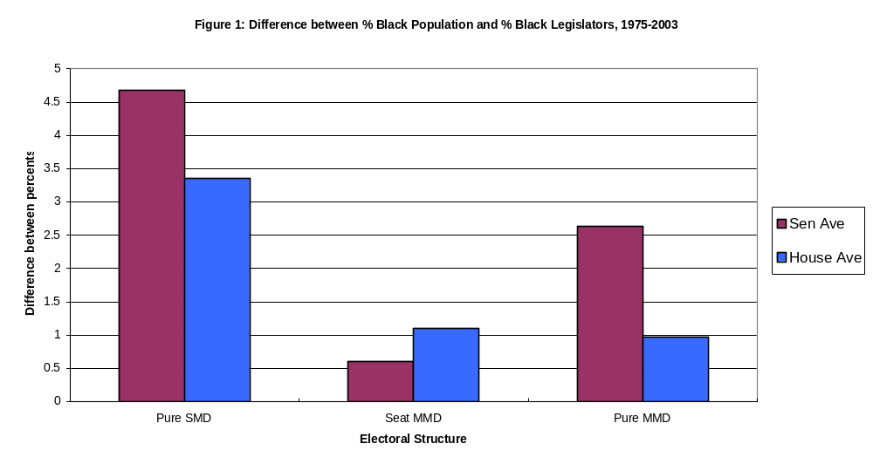
Source: Joint Center for Political and Economic Studies. Data taken from A National Roster of Black Elected Officials, Black Elected Officials: A National Roster, and from their web page, www.jointcenter.org.

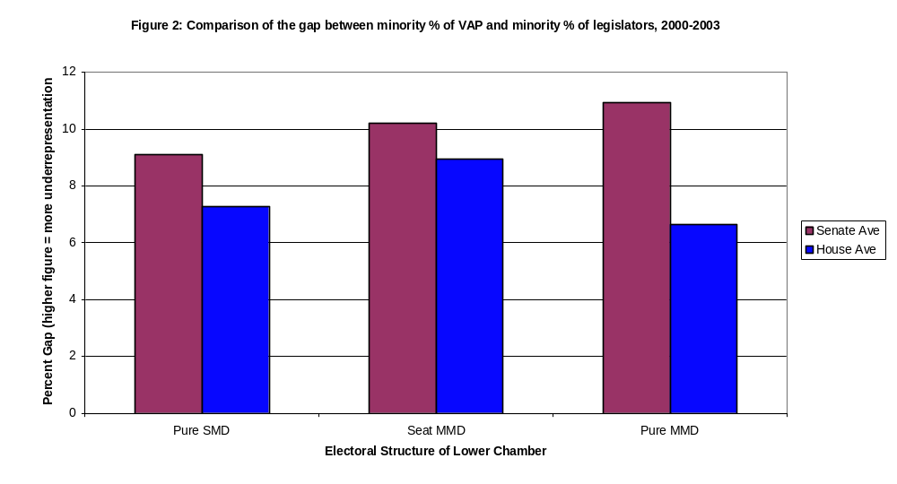
Source: Fairvote.org

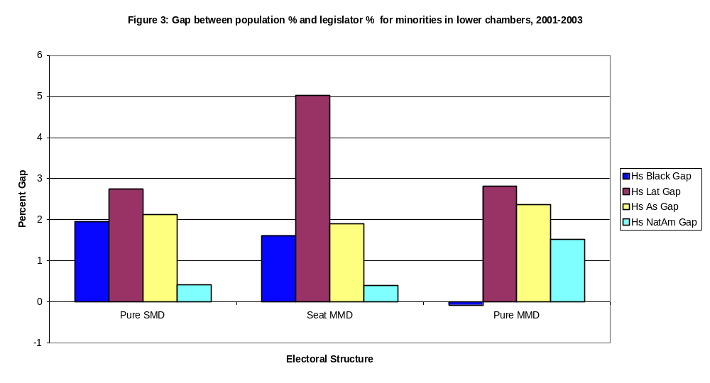
Source: Fairvote.org

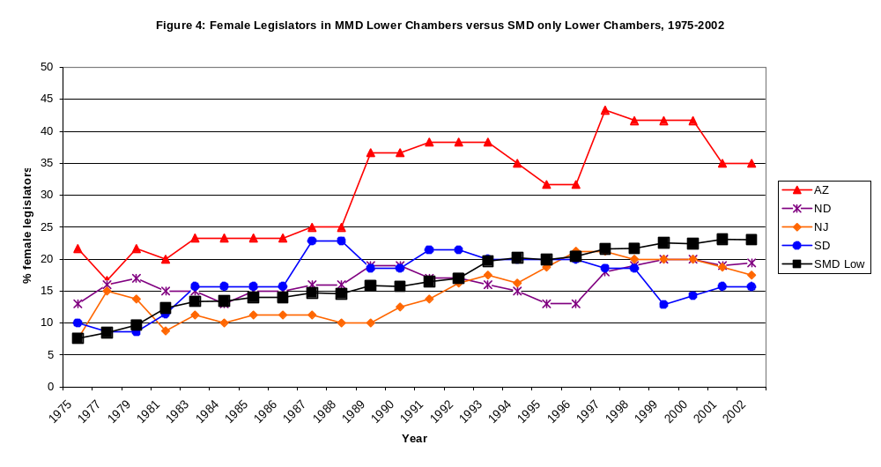
Source: Center for American Women and Politics, Eagleton Institute of Politics, Rutgers University

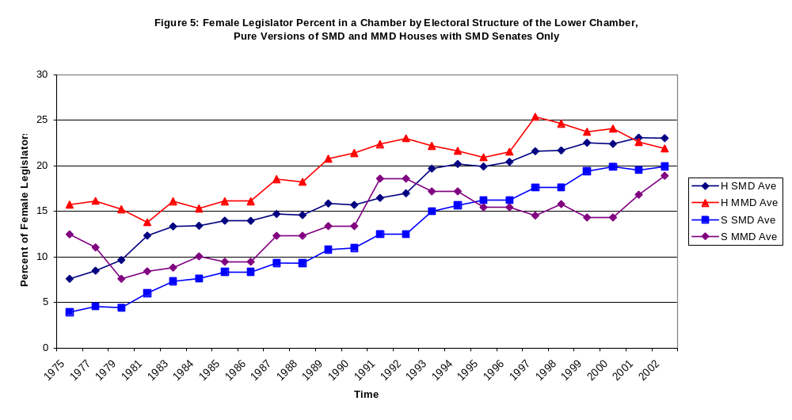
Source: Center for American Women and Politics, Eagleton Institute of Politics, Rutgers University

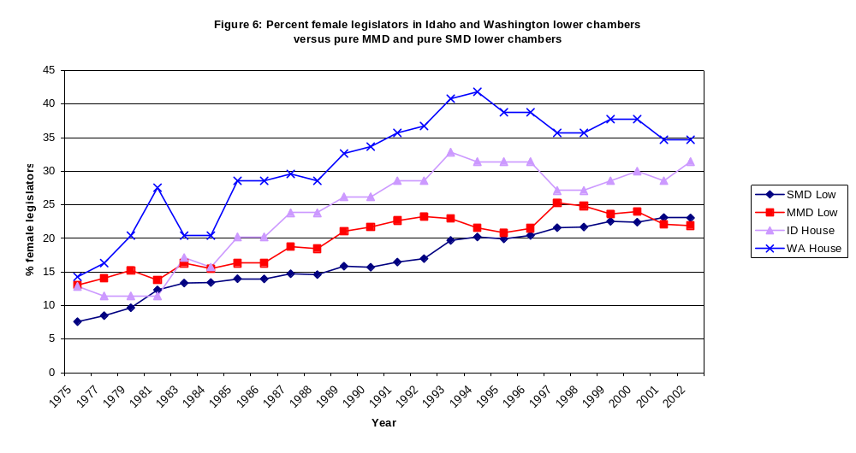
Source: Center for American Women and Politics, Eagleton Institute of Politics, Rutgers University.

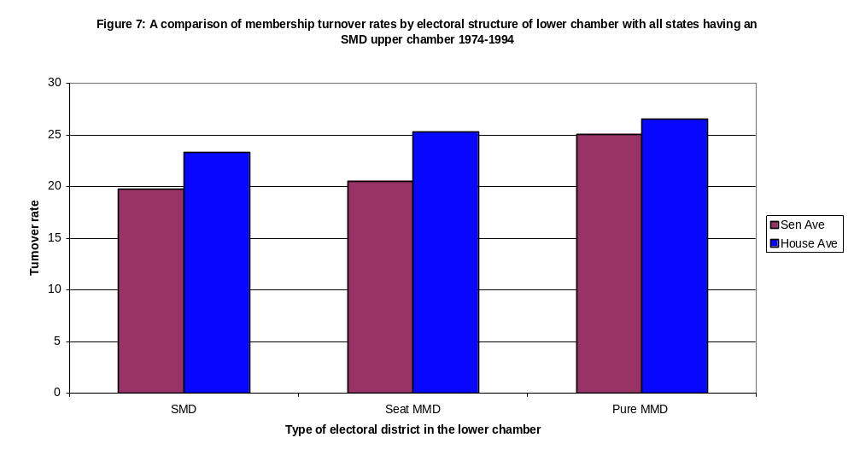
Source: Book of the States, Council of State Governments

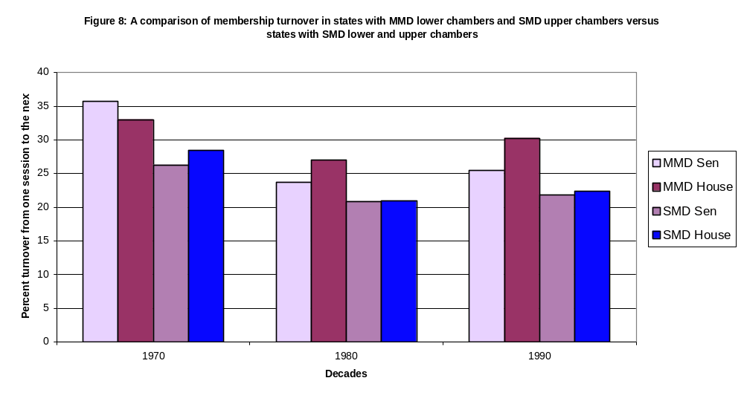
Source: Moncrief, Niemi, and Powell, 2003.

For instance, Alan Rosenthal’s (1998) book on state legislatures does not contain a single mention of MMDs. Dye and MacManus’ (2002) text on state and local politics includes only one paragraph on MMDs in the state legislature, whereas MMDs in local elections are given much more coverage.
Grofman et al’s study is also supplemented with an in-depth look at the North Carolina legislature.
Therefore, we have four “pure” MMD states (AZ, NJ, ND, and SD) and twenty-six “pure” SMD states (AL, CA, CO, CT, DE, IA, KS, KY, LA, MA, MI, MN, MO, MT, NM, NY, OH, OK, OR, PA, RI, SC, TN, TX, UT, UT, WI)
This book, formerly called A National Roster of Black Elected Officials is now called Black Elected Officials: A National Roster. The roster has come out annually since 1973, with the exception of 1983, when no roster was published.
We left Hawaii out of this analysis. Because Asians and Pacific Islanders make up about 62% of the population in Hawaii, it is not appropriate to label them as a minority for this state even though they are in all other states.

