I Don’t See Any Sea Change:

The Recall’s Effects on the Size, Composition,
and Behavior of California’ Electorate

Prepared by Thad Kousser for the
State Politics and Policy Quarterly Conference
April 29-30, 2004, Akron, Ohio

While it attracted enormous media coverage, entertained the nation for a summer, and turned out a large number of voters for an odd-year contest, California’s 2003 recall did not signal a sea change in the state’s politics. Comparing the recall with recent California elections, and putting it in the context of historical examples of sea changes, I find that it falls short in three areas:

• Size of the Electorate. Measured either by the number of registered voters or by turnout, the recall was extraordinary only compared to odd-year special elections that did not feature any candidates. Comparing the electorate’s size in the recall to gubernatorial races held since 1980 demonstrates that its registration and turnout levels were about average.

• Composition of the Electorate. Potentially the most significant effect of the recall was that it increased the number of Republican registrants and decreased Democratic registration in some competitive Assembly districts. However, this effect was limited to that particular political context: Republican registration statewide has only increased by half a percentage point. These trends indicate that the recall mobilized conservative voters who saw great potential benefits from replacing Davis with Schwarzenegger, while Democrats did not perceive heightened stakes.

• Behavior of the Electorate. There was a high level of crossover voting in the October election, just as there has been in recent gubernatorial contests. It appears that most of the Democrats who crossed party lines to support the recall were pushed away from Gray Davis rather than pulled in by Arnold Schwarzenegger, a finding that should leave Democrats other than Davis optimistic about their chances in 2006.

How “special” was the special election that California held on October 7, 2003 to decide on the recall of Gov. Gray Davis? Some observers have claimed that it represented a sea change in California politics, fundamentally altering the electorate and ushering in an era of better times for a Republican Party that fared poorly in recent legislative and statewide contests. This assertion classifies the recall with other momentous elections that mobilized or converted many voters, such as Roosevelt’s 1932 triumph (Anderson, 1979) or the Newt Gingrich-led takeover of Congress in 1994. It ties the 2003 race to a broad political science literature on “critical” or “realignment” elections (Key, 1955 Burnham, 1970, McCormick, 1986). Looking at a range of data, I find that the recall does not fit into this category. Although it certainly led to the political extinction of one particular Democrat, it does not appear to have altered California’s political environment to endanger the entire species of Democrats. Comparing this special election with past elections shows that was about a normal as California contests get.
To evaluate whether the recall brought a sea change to this coastal state, I look at how fundamentally it affected three characteristics of California’s electorate. First, I explore whether it affected the electorate’s size, measured both by the number of registered voters and by voter turnout. Next, I examine the recall’s effect on the composition of California’s electorate to see whether it has brought any fundamental shift in the party breakdown. Finally, I explore its impact on the electorate’s behavior, testing to see what caused some voters to cross party lines in the recall and looking for clues of how they will vote in the future. In all three areas, I find that the recall did not bring any effects that were extraordinary in comparison with California’s recent political history. The few effects that I do find look to be ephemeral, bound in the context of the recall’s particular dynamics and unlikely to have a lasting influence. In short, I don’t see any sea change.
What does this tell us about the recall? Correctly classifying this election as a sea change or not has stakes both for scholars and for political observers. For academic study, finding evidence that the recall permanently altered California’s electorate link it to the literature on direct democracy. One of the most interesting recent avenues in that literature has explored how the exercise of a direct democracy institution has secondary effects on the political system. Gerber (1999) has shown that the use or threat of initiatives changes the policymaking process, and Gerber et al. (2001) note that the impact of initiatives on policy is not always straightforward. Direct democracy can also influence politics: Hiram Johnson’s Progressives gained political stature when they established the initiative, referendum, and recall (Piott, 2003). Showing that the recall not only replaced a governor but had secondary effects on California’s electorates would place it in this context. The important lessons for political observers would be similar. Will Schwarzenegger’s impressive victory give him great influence over legislators who fear his ability to alter the electoral conditions they face? Has the recall shifted the statewide electorate toward the right, making it easier for Schwarzenegger to govern by initiative and assuring his reelection in 2006?
The evidence that I present here indicates that this sort of shift has not occurred. After proposing some hypothesis about how the recall might affect the size, composition, and behavior of California’s electorate, I review each aspect in turn. I conclude that the political effects of the recall have been few and temporary.

I. What Would a Sea Change Look Like, and Why?
One way that an election can bring a sea change to a state’s politics is by enlarging and reshaping its electorate, either by bringing new voters into the system or by turning out experienced voters who had become disillusioned. Anderson (1979) shows that Franklin Roosevelt captured the presidency in 1932 in large part because his campaign galvanized workers who had never before voted. A more immediate example provided by Jesse Ventura, whose insurgent candidacy in the Minnesota governor’s race brought out many young, first-time participants. Even when no new voters are incorporated into the electorate, its size can grow if some constituency is mobilized to reregister and vote at a higher than normal rate. Though it is rarer, those who turn out consistently can switch their party allegiances. When any of these sea change events occur – new voters flock to a charismatic candidate, sometimes voters become mobilized, or regular voters change their registration – the size or the composition of the electorate will shift.
A literature that attempts to formalize the calculus that voters use when deciding whether or not to take part in an election, though often paradoxical, provides some clues as to what might bring a shift in the electorate’s size and shape. Sea change elections should affect two terms in the “calculus of voting.” Riker and Ordeshook (1968) propose that a voter will turn out when her costs of participating are outweighed by the sense of duty she feels plus the product of the benefit she expects if her favored candidate wins and her chances of casting a tie-breaking vote. For an election to cause a sea change, it needs to increase one or more of these terms.
Potential voters will not see their chances of breaking a tie rise in a momentous election, nor will they reevaluate their personal senses of duty. But participation could increase if one set of voters feels that the stakes have been raised. They could expect greater benefits from a victory if a hated incumbent such as Herbert Hoover or Gray Davis, is thrown out. They might also anticipate a bigger payoff if they were especially excited about a candidate running to replace this incumbent. Importantly, this sort of change in participation will be driven only by the potential voters whose stakes in the election have grown. It should not be a universal effect, and those who do not see any change in their expected benefits from the election will not revise their likelihood of voting. In the California recall, this means that those who were excited by Arnold Schwarzenegger’s candidacy or particularly disgruntled at Gray Davis handling of the state should have been drawn into the electorate. Those who saw few potential gains from the conflict may have dropped out of the electoral realm. If the “benefits” term in the calculus of voting changed, we should see high rates of mobilization among Republican voters. This may not change the size of the electorate, but if it does not, it will certainly alter its composition.
The other way in which a sea change election could enlarge the voter pool is by uniformly lowering the costs of voting. In a high-profile contest, obtaining information about the campaign’s main issues, when to register, and when and where to turn out will be easy for everyone. The California recall seems to fit this description. The campaign received an extraordinary amount of coverage, not only in the political press but in outlets such as late night talk shows, morning magazines, and Oprah Winfrey’s program. Although the campaign only lasted 77 days, the contests spent more than $80 million combined in order to pitch their case to voters (Kousser, forthcoming). Knowing that getting out the vote is key to victory, the Davis, Bustamante, and Schwarzenegger campaign devoted considerable resources to sending out absentee ballots and mobilizing voters. If the recall brought a sea change by providing voters with costless information about its details, we should expect to see an increase in participation across the board. The electorate’s size will grow, but its composition will remain constant.
The calculus of voting yields some insights into why an election as special as this one might alter the size and composition of the electorate, and suggests a way to infer from an empirical pattern what causal process is at work. Yet it says nothing about the behavior of voters once they turn out. The key puzzle of voting behavior in recall is why so many voters crossed party lines. Why did a predominantly Democratic state abandon Democratic Governor Gray and elect a Republican to replace him? The fact that Republicans Arnold Schwarzenegger and Tom McClintock combined to receive 62.1% of the vote in the replacement race indicates a possible sea change in voting behavior. Does this reflect the conversion of an identifiable set of Democratic voters to the Republican side, similar to the socially conservative union members who became Reagan Democrats in 1980 and 1984? If so, the implications for future California elections will be profound.
Examining patterns in crossover voting can reveal lessons about the intentions of voters and clues to their future behavior. One conjecture is that Gray Davis made missteps that pushed Democratic voters of all stripes temporarily into the Republican camp. If this is true, Democratic crossover voters should be united only in their disapproval of Davis. They should otherwise look like a cross-section of Democrats, and split between various candidates in the replacement race. Democratic hopefuls in the 2006 gubernatorial contest hope that this is the case, because these sorts of crossover voters would be likely to return to the party fold with Davis out of the race. A competing explanation is that Arnold Schwarzenegger’s candidacies pulled Democrats away from their governor because of the attractiveness of his candidacy. If this is the best explanation, Democratic crossover voters are likely to be the sorts of conservatives and moderates most receptive to his message, and should have voted for overwhelmingly for Schwarzenegger in the replacement race. This situation would echo the permanent conversion of Reagan Democrats, representing a sea change that bodes well for Schwarzenegger’s chances in 2006.

II. Size of the Electorate
Comparing current exit polls and election returns with historical data, I investigate how much the recall enlarged California’s electorate and why it may have done so. I begin with a brief look at the number of new voters brought into the system. Although I do not have a historical baseline to compare it with, this figure is small, and first-time voters were not particularly supportive of the recall. Then I turn to voter registration. The 2003 recall did bring a small upswing in overall registration, a rarity in the odd years between gubernatorial and presidential elections. However, this increase has more than faded away, leaving registration figures back in their typical off-cycle doldrums now that the ephemeral impact of the recall has disappeared. Finally, I look at how many people voted on Election Day. At 61% of eligible voters, turnout in the 2003 recall was higher than turnout in California’s three other statewide special elections, and just above the average in recent gubernatorial contests. Overall, this supposed sea change brought no flood of new voters, a brief tide of new registrants that quickly receded, and no monstrous turnout wave.
It seemed reasonable to predict than an action movie hero who communicated through novel media channels might pull a sizable group of first-time voters into California’s electorate. According to exit polls, few new voters showed up. The Los Angeles Times Exit Poll, conducted at polling places, found that 4% of recall voters were first-time participants. The Edison Media Research/Mitofsky International poll that sampled absentee voters in addition to those at precincts estimated this number at 3%. Since 29.5% of participants voted absentee in this election, and since these are the voters most familiar with the voting process, taking their composition into account is important to answering this question (Shelley, 2003a). Consequently, 3% seems to be the best guess at the percentage of first-time voters. Unfortunately, I could locate no previous exit poll containing this question, preventing me from putting it in historical context.
Looking at how these voters behaved suggests that, regardless of whether or not 3-4% is a “big” figure, their participation made no big difference in the election outcome. First-time voters cast their ballots 57-43% in favor of the recall, while electoral veterans supported it by a 55%-45% margin. Half of them supported Arnold Schwarzenegger, just slightly above the 49% of experienced voters who backed him (Times Poll, 2003). Unlike the blue-collar voters that FDR brought into the system or the young males who flocked to support Jesse Ventura, first-time voters here displayed no extraordinary allegiance to the recall or to Schwarzenegger. It appears that the overall attention given to the race reduced their costs of registering and turning out.
The effect of the recall on the number of registered voters was small and consistent with past patterns. There is no evidence that higher stakes or increased coverage inspired voters whose registration had lapsed to sign up in large numbers. Because California’s population steadily grows, the number of registered voters has increased over time from nearly one million in 1912 to ten million in 1972 to over 15 million today. Fluctuations around this secular trend are usually the result of three factors. First, presidential contests drive registration higher than it is during gubernatorial races. Second, registration tends to dip in the odd years following both types of contests. Third, registration is lower in the spring of election years than it is in the fall, when general elections approach. Figure 1, which presents even year registration figures since 1980, illustrates the impact of this first factor and shows that recall registration was typical, and perhaps a bit low, for gubernatorial elections.
The solid line in Figure 1 tracks the absolute number of registrants across time. It rises as California’s population grows, and is always higher in presidential election years than when the governor’s office is up for grabs. The line flattens as it gets to the open circle marking the 2003 recall. About the same number of voters eligible voters registered for this election as had registered in the 2002 General Election. The dotted line shows that the rate at which they registered actually declined. This line, showing the percentage of eligible voters who are signed up in time for any given election, dips slightly as it reaches the recall. Put in the context of registration for past general elections, the recall looks like a gubernatorial contest that did not attract particularly much attention.
Figure 1. Voter Registration in General Elections, 1980-2003.
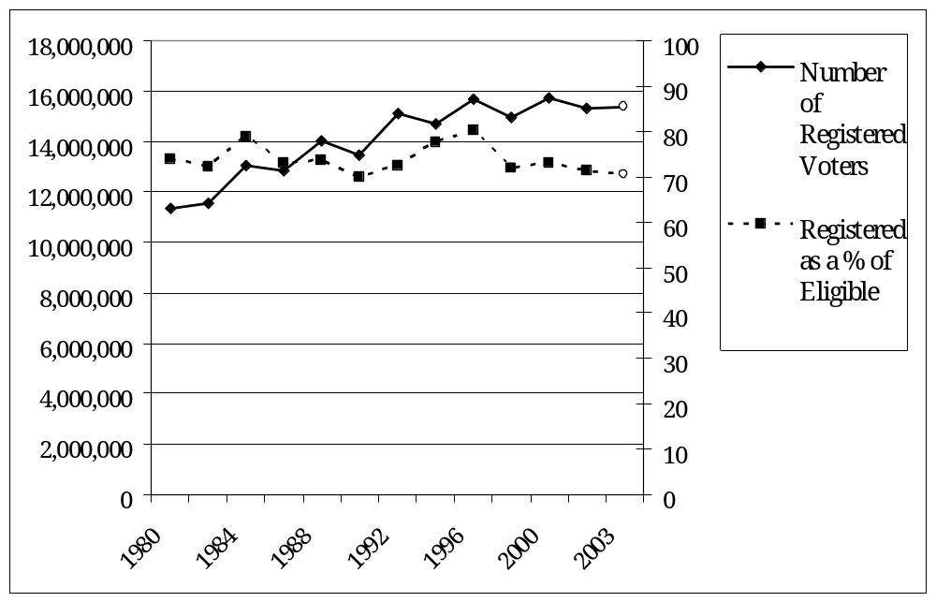
Notes: Taken from Shelley, 2003b.

Figure 2 displays the effects of the other two factors – odd years and the season – on registration, showing that effects of the recall were only temporary. It begins with the 1998 governor’s race, and shows that registration typically tails off in the odd year following such a contest and then jumps again in for the November, 2000 presidential election. Registration drops off from this higher level over the next odd year, then stays steady as the 2002 governor’s race sparks interest. The recall, represented by the open circle, bumps registration slightly higher than one would normally expect for the fall of an odd year. Still, the fact that registration again declined for the March, 2004 primary shows that the increase brought by the recall was ephemeral, and did not stop the typical downslide typical of the period between presidential races.
Figure 2. Voter Registration in February and October, 1999-2004.
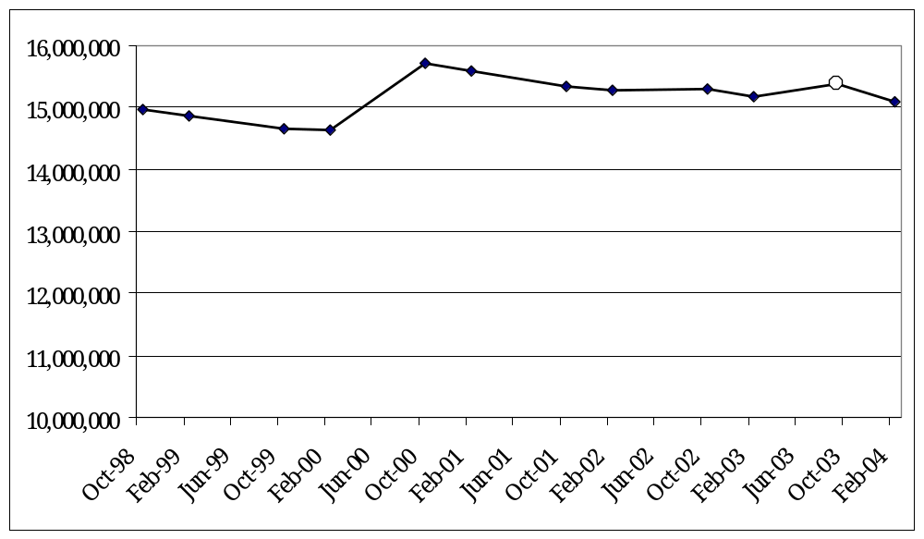
Notes: Values on the y-axis from zero to ten million have been omitted, exaggerating season-to-season fluctuations in order to make them more visible. Data are drawn from the final registration reports issued before each election, archived at http://www.ss.ca.gov/elections/elections_u.htm

Many observers have pointed to Election Day turnout as evidence that the recall dramatically increased the size of the electorate. Indeed, with 61.2% of registered voters casting a ballot, turnout in October, 2003 far surpassed the 50.6% level recorded in the 2002 governor’s race. It also dwarfed the turnout rate in California’s three previous statewide special elections, which averaged 40.5%. At first glance, this seems like spectacular proof that the recall really was “special,” mobilizing a larger electorate that in comparable contests. However, a closer look at what makes a truly comparable election and what turnout has been over a longer time period again shows that this contest was not unique.
None of the three statewide special elections held in California featured any candidates on their ballot; all were exclusively to decide on direct initiatives and legislative amendments. In 1973, 47.6% of registered voters cast a ballot on Proposition 1, a tax and spending limit that was the unsuccessful forerunner to Proposition 13 (Murphy, 1973). Another spending limit, Howard Gann’s Proposition 4, brought 37.4% of registered voters to the polls to vote on it and three legislative amendments in 1979 (Eu, 1979). In 1993, a mere 36.4% of those registered turned out to decide on six measures proposed by the Legislature and a vouchers initiative, Proposition 174 (Eu, 1993). Although each was certainly an important issue of the day, none generated the media coverage or campaign spending that the recall did. Propositions in general attract less attention that candidate campaigns. The propositions that were on the ballot with the recall were voted on by only 54.3% (Proposition 53) and 56.5% (Proposition 54) of registered voters (Shelley, 2003a). Because people turn out more voters than policies, it makes little sense to compare the recall of Gray Davis with previous special elections that lacked candidates.
The best way to evaluate the interest that it generated is by comparing to other recent presidential and gubernatorial general elections. Figure 3 does so, presenting turnout rates since 1980. It shows that turnout, whether measured as a percentage of registered or of eligible voters, has decline slightly over this period and is always higher in presidential years. This chart also highlights what an anomaly Gray Davis’ 2002 reelection was, posting what is by far the lowest turnout of any regularly scheduled election for at least 90 years (Shelley, 2004). More typical are the governor’s races in 1986, 1990, 1994, and 1998, all of which had turnout levels that were approximately 60% of registrants. Judging by these figures, Arnold Schwarzenegger’s candidacy did not thrill and mobilize California voters any more than the campaigns by George Deukmejian, Pete Wilson, and even, in 1998, Gray Davis.
Figure 3. General Election Turnout, 1980-2003.
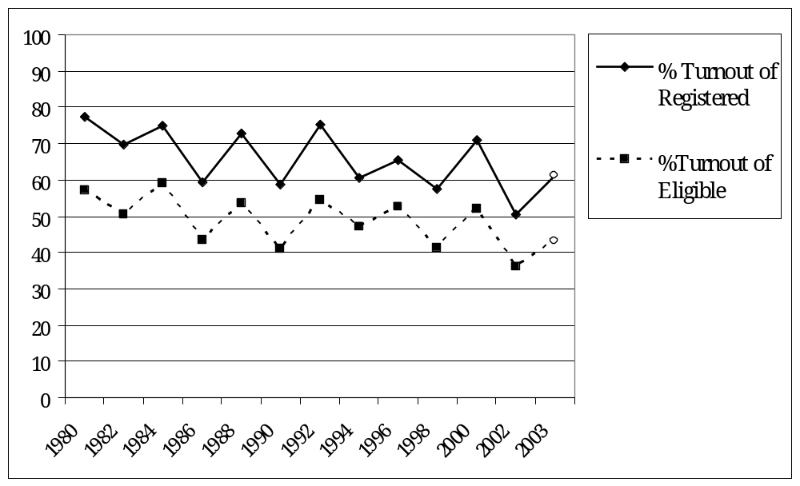
Notes: Taken from Shelley, 2004b.

II. Composition of the Electorate
Even though the California electorate’s size remained constant during the recall, the October, 2003 contest did affects its composition slightly. It brought a noticeable surge in Republican affiliation, but whether partisan composition is measured by looking at registration or at turnout, all of the effects of the recall prove temporary. In the spring of 2004, Republicans statewide do not look much better off than they did in spring of 2002. This section uses the Secretary of State’s figures to examine the composition of registered voters over the past few contests, and then looks at the breakdown of those who turn out by comparing recent exit polls. Although the detectable shifts do not amount to a sea change, they may signal a mood shift in key legislative districts.
Tracking party registration numbers from February, 2002 through the recall to February, 2004 reveals a subtle shift in the electorate’s composition: Republicans rise and decline, Democrats fall, and those who do not affiliate with a major party make up a steadily increasing portion of potential voters. Shelley (2002b, 2003b, 2004b) reports that Democratic registration declined nearly two percentage points, Republican registration rose by half a point, and those who did not affiliate with one of these made up the difference. Putting aside the last category for a moment, I focus on the two major parties.
A politically meaningful way to look at the scale of these percentage changes is to focus on Assembly districts. The 80 California Assembly seats average 191,000 registered voters, although they ranged from 94,266 to 272,033 in February, 2002 (Shelly, 2002b). On average, the Democratic Party lost about 2000 registrants per district from 2002 to the recall, and then another 2500 from the recall to the 2004 primary. Republicans gained nearly a thousand voters per district as the recall approached, then lost nearly half of them by 2004. This difference between the parties indicates that the decisions of voters choosing whether or not to participate in the recall were driven by the benefits they expected to receive from having their side win. If it were the costs of voting that drove their decisions instead, all types of voters would have received the easy-to-obtain information about the race and registered. But that fact that Democrats dropped off the rolls at a time when Republicans added themselves implies that Republicans saw more to gain from the recall. They may have been as excited about a Schwarzenegger candidacy as Democrats were unmotivated to defend Davis. This is the type of causal mechanism that leads to a change in the electorate’s composition while its size remains steady.
Another wrinkle in registration patterns is the presence of systematic variation beneath these aggregate party trends. Examining this variation gets at the question of why some voters might perceive greater stakes in a given election. Under the simplest form of the hypothesis I have pulled from the calculus of voting, Republicans everywhere across the state should behave one way while Democrats universally behave another way. This is not what has happened. Dividing districts into different groups based on their partisanship reveals what sort of process might be driving the change in partisan composition suggests how it may affect future races.
I divide Assembly districts into three categories, based on their February, 2002 makeup. “Republican Districts” are the 20 districts in which Republican registration was at least ten percentage points higher than Democratic registration. I categorize the 16 seats in which neither party held a registration edge greater than ten points as “Competitive Districts.” In the remaining 44 districts, the Democratic Party held a registration advantage of more than ten percentage points, making the seat a “Democratic District.” Looking at their differences holds lessons not only for political scientists interested in determining what guides electoral behavior, but also for political observers who want to know how the recall might shape outcomes in the next legislative elections.
I examine competitive districts first, because they look like the state overall. Figure 4 shows that Republican registration surged then fell back slightly in these districts, while the Democratic Party consistently lost membership. From 2002 through 2004, the Republican edge in the average competitive district rose from approximately 2600 to 6300 voters. This may be an ominous sign for vulnerable Democrats. In conservative strongholds, Republican
Figure 4. Democratic and Republican Registration, by partisanship of district.
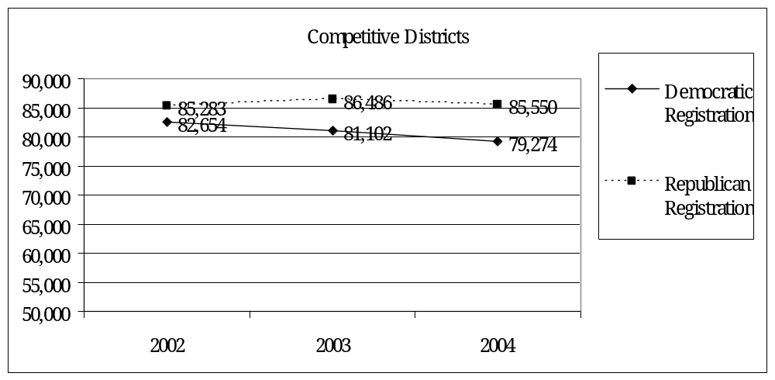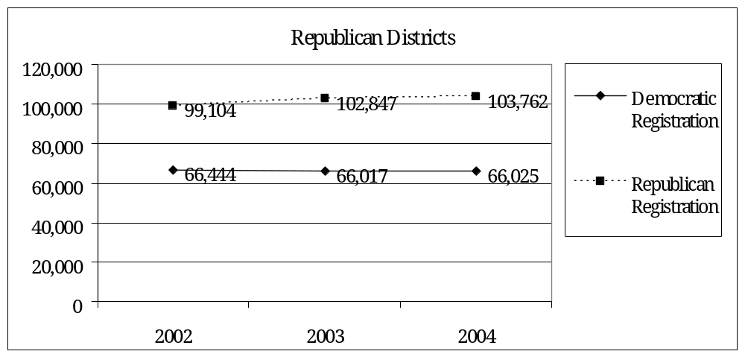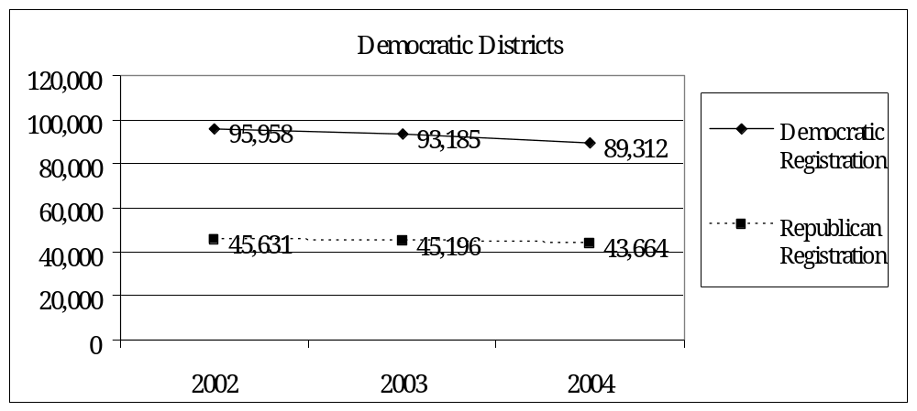
Notes: Average numbers of registered voters in district types taken from Shelley (2002b, 2003b, 2004b).
registration increased with the recall and kept rising in 2004. Surprisingly, Democratic registration hardly dropped at all in these areas. Registration levels for both parties were depressed in Democratic districts, with the Republican Party losing even more registrants than the Democrats in liberal seats.
Some post hoc reasoning may explain why the forces that mobilized voters were geographically isolated. Perhaps broadcast media strategies and widespread mobilization efforts reached voters of all stripes in conservative areas like Orange and San Diego Counties. This would explain why the recall brought relatively high registration levels to both parties in Republican districts. In competitive districts, perhaps the pro-recall forces targeted their message a bit more tightly, using strategies like direct mail and phone banks that reached only their base. Divergence in party patterns in close Assembly districts would be the expected outcome under this scenario. If campaign events and commercials were rarer in Democratic areas such as San Francisco, one would expect registration for both parties to drop.
Omitted from the analysis above are those who do not register with a major party, the fastest growing category of voters. Shelley (2004b) reports that this group increased from 19.9% of registrants in February, 2002 to 21% in October, 2003 to 21.2% in February, 2004. It is important to note that these figures combine the percentage of Californians registered with a minor party (which turns out to be a minor number) along with the percentage who register as "Decline to State" voters. By forsaking party membership, these voters excluded themselves from participation in any primary up until 1998. Like all California voters, they were free to take part in any primary in 1998 and 2000. Unlike any other Californians, in the 2002 and 2004 primaries they were invited to become a Democrat or a Republican for the day. Minor party registrants were not extended this courtesy. In short, someone was fed up with the major parties – but still wanted the chance to affect one of those party's primaries – the new election laws channeled them toward the decline to state column. Perhaps this explains why while minor party registration dropped from 5.2% in 2002 to 5.0% in 2003 and 4.8% in 2004, the Decline to States voters rose from 14.7% of the electorate in 2002 to 16.0% in 2003 to 16.4% in 2004.
Returning again to Democrats and Republicans, I compare a series of exit polls to examine the composition of the voters who actually turn out. Figure 5 matches the recall against other recent primaries and general elections, showing that it brought a pro-Republican shift. Democrats only held a 43% to 32% edge on October 7, 2003, much smaller than the 6-12% advantage they had held in previous elections. Since the changes in
Figure 5. The Partisan Composition of the California Electorate, exit polls estimates.
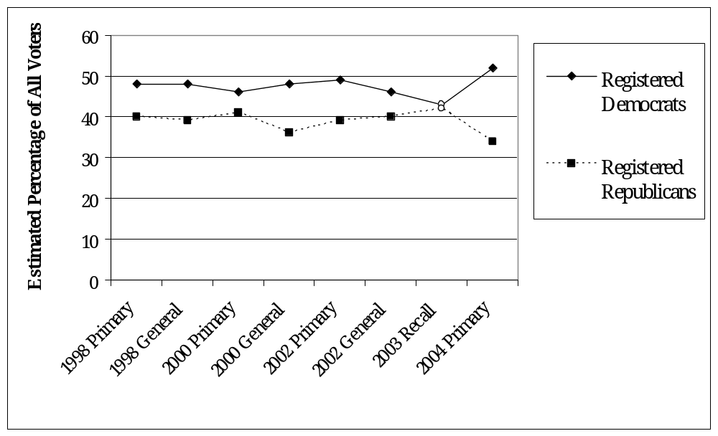
Notes: Each partisan breakdown is taken from the appropriate report issued describing the Los Angeles Times exit poll, and is archived at http://www.latimes.com/news/local/timespoll/state/.

registration discussed above were not this dramatic, it is clear that Republican turnout in the recall was higher than Democratic turnout.
Before concluding that this Republican surge represents an unprecedented sea change, consider other elections held before and after the recall. While 2003 was a good year for California Republicans, it was not as good as 1994, when the Gingrich revolution, Pete Wilson, and Propositions 184 and 187 actually gave them 41%-40% edge over Democrats. That advantage helped give them control over the state Assembly, but it eventually faded away. The pro-Republican shift in the recall has disappeared even more quickly. In the 2004 primary, Democrats held their biggest lead in the composition of Election Day voters, with a 52% to 34% edge. Certainly, the Democratic primary featured more candidates, but John Kerry’s nomination victory was all but assured by the time Californians got to the polls. The 2004 general election will render a more definite verdict, but the lesson of the primary is that the recall’s impact on the partisan composition of voters has already disappeared.

IV. Behavior of the Electorate.
This section examines crossover voting, defined as a voter supporting a candidate who does not represent the party with which the voter is registered. A Democrat who supports a Republican, the Green nominee, or a Reform Party candidate has crossed over. The recall question necessitates a special definition of crossover voting: a Democrat who bucked her Party’s recommendation and voted to recall Gray Davis crossed over, as did a Republican who opposed the recall. I begin by describing the frequency of crossover voting, as estimated by the exit polls conduction by the Los Angeles Times on recent election days. Figure 6 reports crossover rates for members of each major party in recent statewide elections.
The first clear lesson is that Republican have typically, but not exclusively, been more loyal to their Party’s nominees than have Democrats. In the six contests tracked below, an average of 12% of Republican voters crossed over, while mean Democratic crossover was 21%. Yet these rates vary with the dynamics of each election: Pete Wilson attracted nearly a fifth of Democratic voters and kept nine in ten Republicans with him in 1994, while Gray Davis reversed these figures in 1994. The 2000 Bush/Gore race was more polarized, with neither candidate attracting much crossover support.
Figure 6. Crossover Voting in California Election, by party.
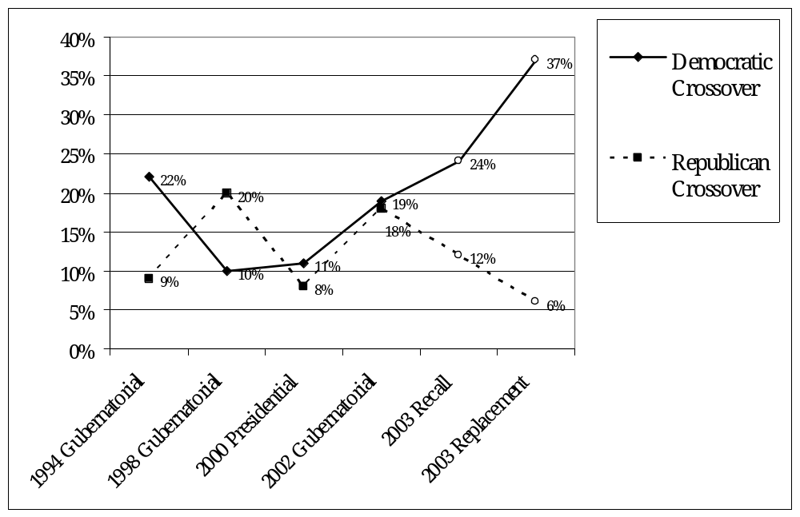
Notes: Crossover is defined as the estimated percentage of a party’s voters that vote for a candidate from another party, and is taken from the appropriate report issued describing the Los Angeles Times exit poll, archived at http://www.latimes.com/news/local/timespoll/state/

An especially intriguing pattern emerges in Gray Davis’ 2002 reelection. He pulled in nearly as many Republican voters from Bill Simon (12%) as he had from Dan Lundgren (18%) during his 1998 landslide. What prevented him from gaining a convincing margin of victory was that, unlike previous statewide winners, he was unable to keep Democrats on his side. In 2002, 19% of Democrats would not support him. More than anything, this was the sign of his electoral weakness leading into the recall campaign. It also suggests that Davis pushed Democrats out of his camp before Schwarzenegger’s candidacy had the opportunity to pull them away. Nearly a quarter of Democrats voted to recall Davis in 2003, but this represents a crossover rate that was only five percentage points higher than it was during his reelection victory. From this perspective, it becomes clear that the recall’s success was not driven by Democrats abandoning Gray Davis; many of them had already left him a year earlier.
The other contest that yields a remarkable pattern in crossover voting is the 2003 race to replace Gray Davis, held on the same ballot as his recall. Republicans were notably loyal, with only 6% of voters straying from their Party’s two major contenders, Schwarzenegger and McClintock. Democratic crossover skyrocketed to 37% as Cruz Bustamante was unable to retain much Democratic support. Is this a sign of things to come in 2006? Will the Republican in that race, presumably Gov. Schwarzenegger, continue to attract enough Democrats to win in a still-Democratic state? It is important to consider the special dynamics of a special election with 135 candidates. Democrat Cruz Bustamante, apparently predicting that he could win the race with 30% of the vote, ran as a liberal and targeted staunch Democrats. It is unsurprising, then, that many Democrats did not support him. Also note that they had two major Republican candidates to choose from, as well as a Green Party nominee, Peter Camejo, who was invited to many debates and performed well (Kousser, forthcoming). Eight percent of Democrats supported the conservative but experienced McClintock, and eight percent backed a minor candidate. This left 21% of Democrats supporting Arnold Schwarzenegger. That is a strong showing, certainly, but not much higher than the crossover support attracted by Pete Wilson in 1994 (19%) and Gray Davis in 1998 (18%). Schwarzenegger did not pull in many more crossover voters than Wilson and Davis did, and Figure 6 shows that their successes were fleeting.
Analyzing the 2003 Los Angeles Times exit poll dataset, now archived at the Roper Data Archive, provides more clues about why Democrats crossed over to support the recall. Some traction on the question why they crossed over can be obtained by who they were, and how they voted in the replacement race. After providing some descriptive statistics, I estimate a multivariate model that tests competing explanations of their choices. Because I do not use the Times’ weighting variable in any of these analyses, the figures I present are slightly different than those the Los Angeles Times itself might produce. For instance, 22% of my Democratic cases crossed over, compared to an estimate of 24% once respondents are weighted.
If frustration with Gray Davis pushed Democrats of all types away from his side in the recall, we would expect crossover voters to unanimously disapprove of him but to otherwise look like Democrats overall. Indeed, 95% of the Democrats who crossed over disapproved of the job that Davis was doing, compared with 52% of Democrats overall. Another way to view the impact of disapproval on their decisions is to whether it can predict crossover behavior. Among Democrats who approved of the job Davis was doing, only 3% voted for the recall. Among Democrats who disapproved, 43% supported the recall. I will examine the strong bivariate relationship in the context of a more nuanced model presently.
Comparing the self-reported ideologies of Democrats who crossed over with Democrats overall shows that while crossover voters were a bit more conservative than the Party as a whole, they are lumped entirely in one side of the ideological distribution. Figure 7 shows that while 57% of California Democrats who turned out for the recall were somewhat or very liberal, 39% of those who crossed over fit this category. Only 10% of Democrats overall labeled themselves somewhat or very conservative, while 20% of crossover voters placed themselves at the right of the spectrum. These two groups are not identical. Still, crossover voters are surprisingly liberal. They came from all wings of the Democratic Party, and it does not appear that they supported the recall because they were moderates who wanted to correct the leftward course upon which Gray Davis had steered the state.
Figure 7. Ideological Distribution of All Democrats and Crossover Voters.
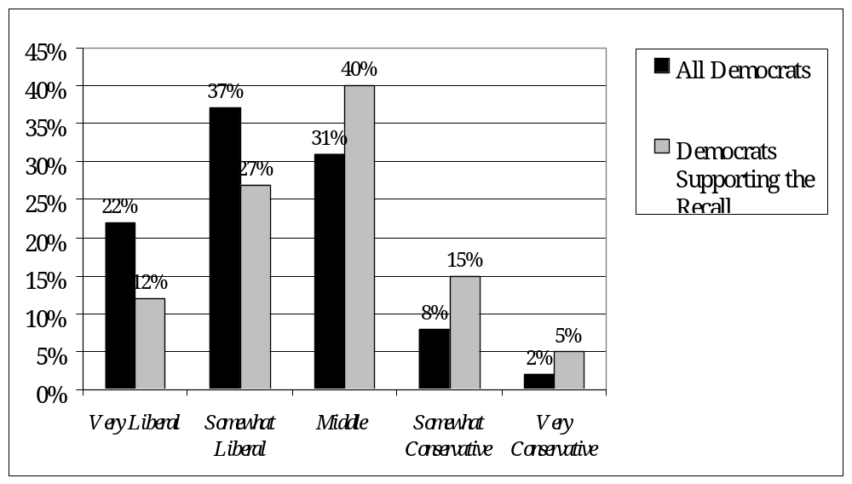
Notes: Figures compiled by the author from the Los Angeles Times October 7, 2003 exit poll.

Further clues can be drawn by observing how crossover voters behaved in the replacement contest. If Arnold Schwarzenegger pulled these Democrats away from Gray Davis in the first part of the ballot, they should flock to him in the second part. An estimated 64% of them did so. Another 15% of Democrats voted for arguably the most conservative candidate in the race, Tom McClintock. But 21% of those who voted against Gray Davis either supported Democratic nominee Cruz Bustamante, voted for a minor candidate, or did not cast a replacement ballot at all. It appears that Schwarzenegger was a strong draw for crossover Democrats, but his presence was by no means responsible for drawing all of the crossover voters away from Davis.
Figure 8. Replacement Candidate Support by All Democrats and Crossover Voters.
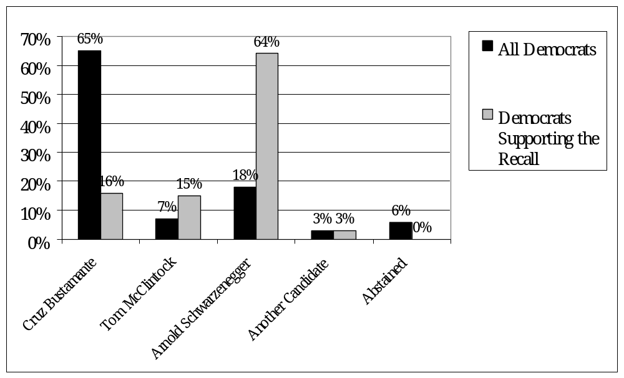 Notes: Figures compiled by the author from the Los Angeles Times October 7, 2003 exit poll.

To adjudicate between these competing hypotheses – that disapproval of Gray Davis pushed Democrats of all types away from him or that support for Schwarzenegger by moderate-to-conservative Democrats pulled them away from their party – I estimate a model of the decision to crossover. It pits the effect the respondent’s approval of Davis against her ideology, holding other characteristics constant. Figure 9 displays first differences in a logit model predicting the choices of 2104 Democratic voters. Each row shows the effects of changing one explanatory variable, when all other factors are held at their median values. This “baseline” case is a somewhat liberal white female who disapproves of the job Davis is doing and sees California’s economy headed in the wrong direction. Based purely on these characteristics, her expected probability of crossing over and supporting the recall is 39%.
Figure 9. Effects of a Democratic Voter’s Characteristics on Her Chances of Crossing Over in the Recall.
When this characteristic | Shifts from … to … | Change in probability of crossing over  (upper and lower bounds)
Ideology | very liberal to moderate | 28% increase  (22%, 33%)
Ideology | moderate to very conservative | 25% increase  (21%, 29%)
Gray Davis Job Approval | approve to disapprove | 36% increase  (32%, 41%)
Appraisal of the Economy | doing well to doing badly | 11% increase  (5%, 17%)
Gender | female to male | 0.2% increase  (-5%, 6%)
Is Voter Latino? | no to yes | 2% increase  (-6%, 10%)
Is Voter Black? | no to yes | 9% decrease  (-17%, 0.4%)
Is Voter Asian? | no to yes | 4% decrease  (-16%, 10%)
Is Voter Native American? | no to yes | 4% increase  (-24%, 32%)
Notes: Boldface indicates that the 95% confidence interval around a simulated first difference did not contain zero, signifying statistical significance. Based on a logit model estimated in Stata 8.0, with first differences drawn from 1000 simulations performed by CLARIFY (Tomz, Wittenberg, and King). 2104 observations. Pseudo R-square of 0.29.

The respondent’s view of the job that Gray Davis was doing is the strongest predictor of her chances of crossing over. A Democrat who disapproved of Davis was 36% more likely to cross over and support his recall that a Democrat who was similar in all other measured characteristics. This effect is statistically significant, and its magnitude is larger than a two-unit shift in ideology, either from very liberal to moderate (28% increase) or moderate to very conservative (25% increase). Comparing these effects suggests that it the push away from Gray Davis was more powerful than Schwarzenegger’s pull on voters who shared his ideology. Those who thought California’s economy was headed in the wrong direction were 11% more likely to vote for the recall, but the gender and ethnicity of voters produced no significant effects. The overall lesson here is that while ideology played a large role in determining support for the recall, it was really disapproval of Davis by Democrats across the spectrum that led to a high level of crossover voting. This effect is likely to be limited to the context of the recall and Gray Davis. Instead of heralding a sea change in which moderate to conservative Democrats shifted into the Republican camp, it seems consistent with the cyclical patterns in crossover apparent in recent gubernatorial races.

Conclusions
While it attracted enormous media coverage, entertained the nation for a summer, and turned out a large number of voters for an odd-year contest, California’s 2003 recall did not signal a sea change in the state’s politics. Comparing the recall with recent California elections, and putting it in the context of historical examples of sea changes, I find that it falls short in three areas:
• Size of the Electorate. Measured either by the number of registered voters or by turnout, the recall was extraordinary only compared to odd-year special elections that did not feature any candidates. Comparing the electorate’s size in the recall to gubernatorial races held since 1980 demonstrates that its registration and turnout levels were about average.
• Composition of the Electorate. Potentially the most significant effect of the recall was that it increased the number of Republican registrants and decreased Democratic registration in some competitive Assembly districts. However, this effect was limited to that particular political context: Republican registration statewide has only increased by half a percentage point. These trends indicate that the recall mobilized conservative voters who saw great potential benefits from replacing Davis with Schwarzenegger, while Democrats did not perceive heightened stakes.
• Behavior of the Electorate. There was a high level of crossover voting in the October election, just as there has been in recent gubernatorial contests. It appears that most of the Democrats who crossed party lines to support the recall were pushed away from Gray Davis rather than pulled in by Arnold Schwarzenegger, a finding that should leave Democrats other than Davis optimistic about their chances in 2006.

Works Cited
Andersen, Kristi, 1979. The Creation of a Democratic Majority, 1928-1936 (Chicago: University of Chicago Press).

Burnham, Walter Dean, 1970. Critical Elections and the Mainsprings of American Politics, (New York).

Eu, March Fong, 1979. California Ballot Pamphlet, Special Statewide Election, November 6, 1979 (Sacramento: California Secretary of State, 1979)

Eu, March Fong, 1993. California Ballot Pamphlet, Special Statewide Election, November 2, 1993 (Sacramento: California Secretary of State, 1993)

Gerber, Elisabeth R., Arthur Lupia, Mathew McCubbins, and D. Roderick Kiewiet, 2001. Stealing the Initiative: How State Government Responds to Direct Democracy (Upper Saddle River, NJ: Prentice Hall).

Gerber, Elizabeth, 1999. The Populist Paradox: Interest Group Influence and the Promise of Direct Legislation (Princeton, NJ: Princeton University Press).

Key, V.O. Jr., 1955, “A Theory of Critical Elections,” Journal of Politics, XVII:3-18.

Kousser, Thad, forthcoming. “The California Governor’s Recall,” The Book of the States, 2004 (Lexington, KY: The Council of State Governments).

McCormick, Richard L., 1986. The Party Period and Public Policy (New York: Oxford University Press).

Murphy, George, 1973. Proposed Amendment to Constitution, Initiative Constitutional Amendment, Together With Arguments (Sacramento: California Secretary of State, 1973)
Piott, Steven L., 2003. Giving Voters a Voice: The Origins of the Initiative and Referendum in America (Columbia: University of Missouri Press).

Riker, William H., and Peter C. Ordeshook, 1968. “A Theory of the Calculus of Voting,” American Political Science Review 62:25-42.

Shelley, Kevin, 2002a. Statement of Vote, 2002 Primary Election. California Secretary of the State, 2002. Accessed at http://www.ss.ca.gov/elections/sov/2002_primary/contents.htm in April, 2004.

Shelley, Kevin, 2002b. February 19, 2002 Report of Registration. California Secretary of the State, 2002. Accessed at http://www.ss.ca.gov/elections/ror_021902.htm in April, 2004.

Shelley, Kevin, 2004a. Statement of Vote, 2004 Presidential Primary Election. California Secretary of the State, 2004. Accessed at http://www.ss.ca.gov/elections/sov/2004_primary/contents.htm in April, 2004.

Shelley, Kevin, 2004b. February 17, 2004 Report of Registration. California Secretary of the State, 2004. Accessed at http://www.ss.ca.gov/elections/ror_02172004.htm in April, 2004.

Shelley, Kevin. 2002c. Statement of Vote, 2002 General Election. California Secretary of the State, 2002. Accessed at http://www.ss.ca.gov/elections/sov/2002_general/contents.htm in April, 2004.

Shelley, Kevin. 2003a. Supplement to the Statement of Vote, 2003 Statewide Special Election. California Secretary of the State, 2003. Accessed at http://www.ss.ca.gov/elections/sov/2003_special/contents.htm in April, 2004.

Shelley, Kevin. 2003b. September 22, 2003 Report of Registration. California Secretary of the State, 2003. Accessed at http://www.ss.ca.gov/elections/ror_092203.htm in April, 2004.

Tomz, Michael, Jason Wittenberg, and Gary King. 2001. CLARIFY: Software for Interpreting and Presenting Statistical Results. Cambridge, MA: http://Gking.Harvard.Edu)

Some of the myriad ways in which Davis alienated Democratic leaders and voters are documented in Kousser (forthcoming).
These figures are drawn from the Los Angeles Times Exit Poll. Because first-time voters are such a small group, the Edison-Mitofsky poll reported their behavior along with those who “rarely” vote. Combined, these voters supported the recall by a 65%-35% margin, compared to the 54-46% margin among voters who claim to “always” or “usually” vote.
Although they were allowed to cast a ballot in the 2000 presidential primary of their choosing, voters who were not Republicans or Democrats respectively would not have their votes counted by the RNC and DNC for the purposes of selection convention delegates.
The proportion of Democrats that Pete Wilson attracted (19%) and the Republicans who voted for Gray Davis (18%) are not as large as each Party’s crossover rates reported in Figure 6, because voters could also cross over to vote for a minor party candidate.
A series of polls over the course of the recall campaign, compiled by Gary Jacobson and reported in Kousser (forthcoming) confirms that Democratic support for the recall hovered around 25% throughout the campaign. The trend of increasing support for the recall over time was driven by the rise in support for it among independent voters and Republicans.

